

SFDC Sales Playbook

Table of Contents
Leads 1
Opportunity 1
Activities & Events 1
Log an Event from an Outlook Appointment 1

Leads

Opportunity

Activities & Events

Log an Event from an Outlook Appointment

- Ensure the SFDC outlook plug is installed
- Navigate to the appointment
- Select the SFDC View Icon
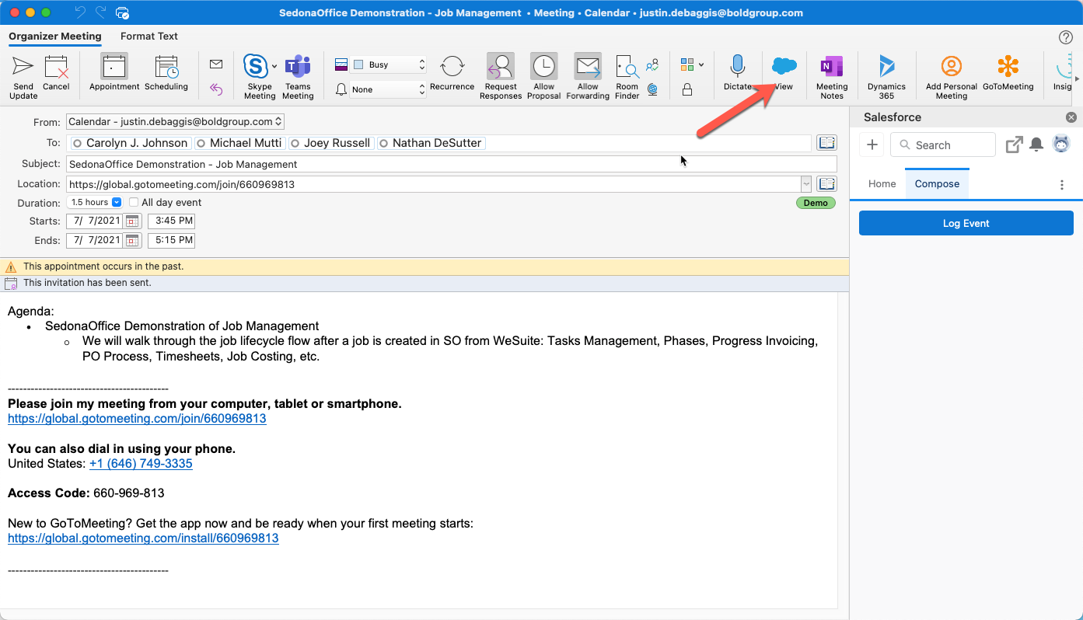
- Select Log Event
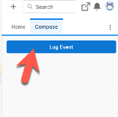
- Select Event Type
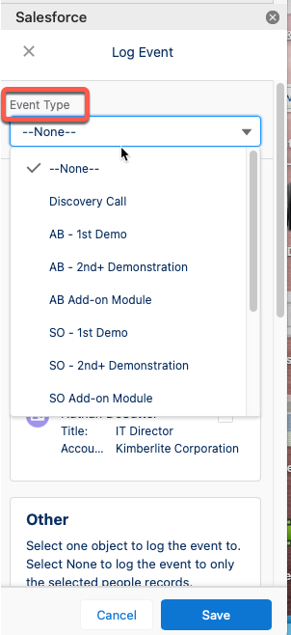

- Select the primary contact
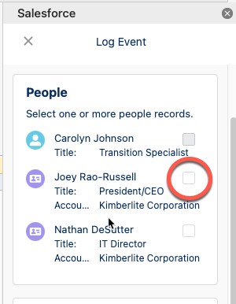
- Select the Opp
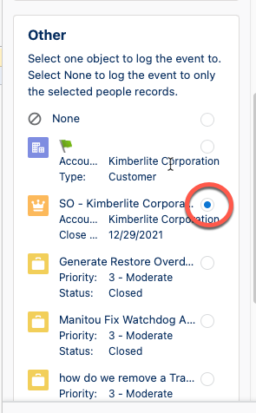
- Select Save
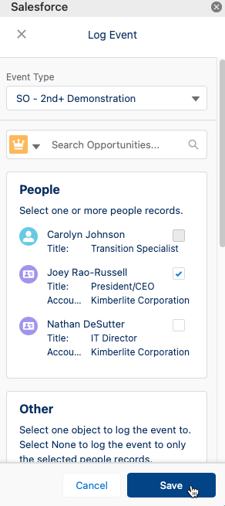
- If you need to edit the logged event, select Edit Logged Event
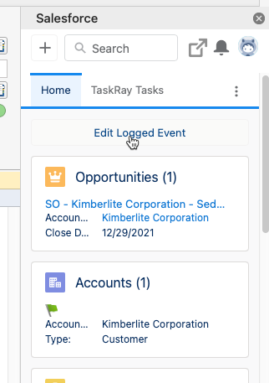
- Navigate to SFDC to view the logged event
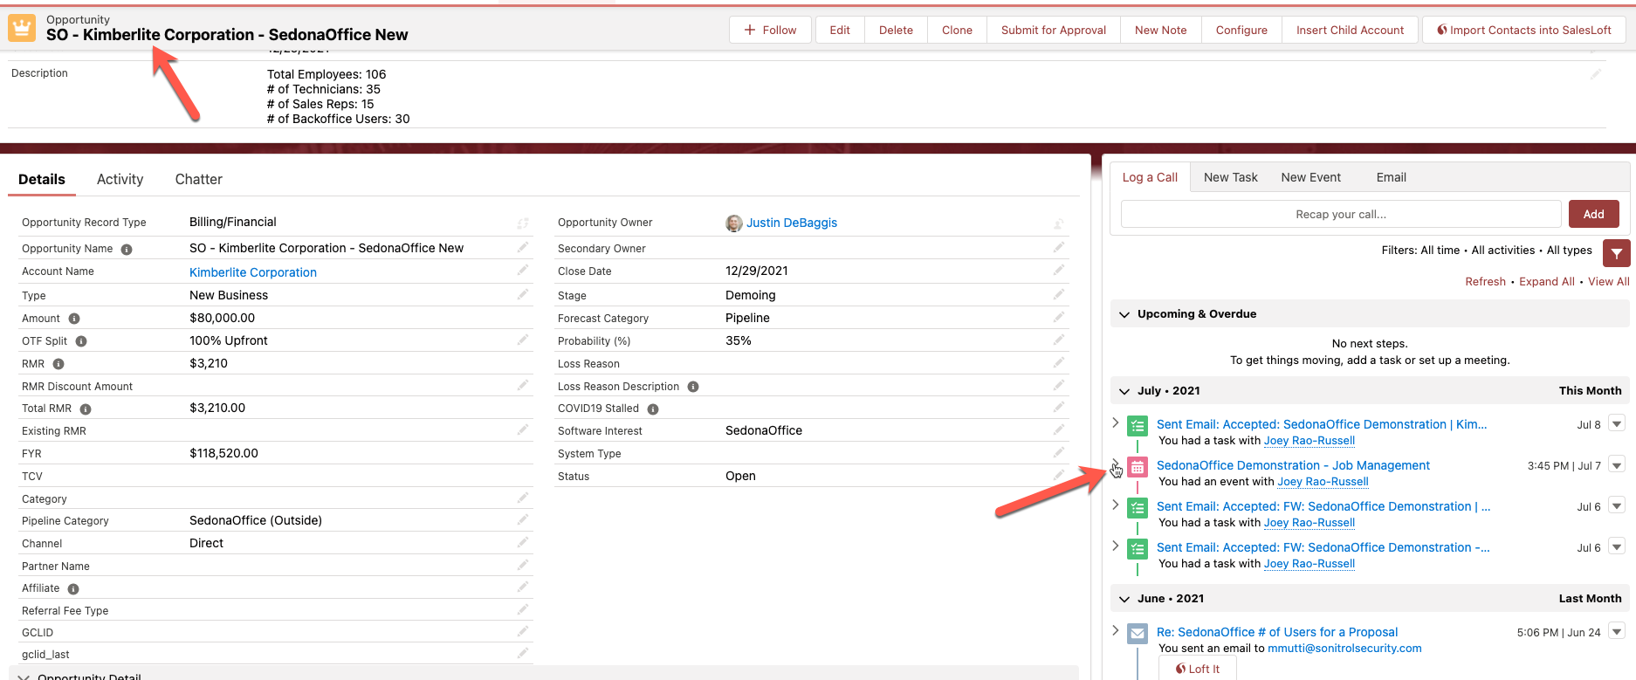
- Edit the Event to review all details
