SFDC Changes
Requested Date 2.8.23
Requested by: Justin DeBaggis and Brent Steinberg
Case Number: 00006699

New Fields Needed for Alarm and Business Management

- New Field Name: Risk Level
  - Object: Opportunity
  - Field Type: Picklist
  - Picklist Options: Low, Medium, High (these will be color coded based on the color scale below)
  - Colors: Low, Medium, High similar to the custom health flag at the account level
  - Location: Opportunity Detail under Next Step
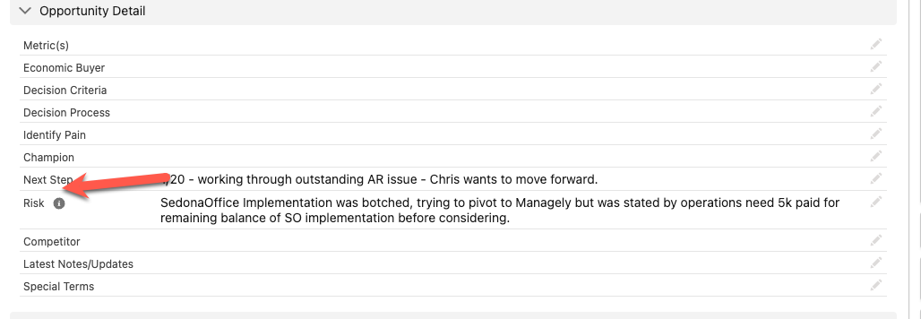

- New Field Name: Risk Reason
  - Object: Opportunity
  - Field Type: Multi-Select Picklist
  - Options: CSAT Support, CSAT Professional Services, CSAT Billing, Missing Feature, Missing Integration, Competitor, Account Hold, Budget, Radio Silent, Other
  - Location: Opportunity Detail under Risk Level (#1 above)

Modify Name of Field
  - Current Field Name: Risk
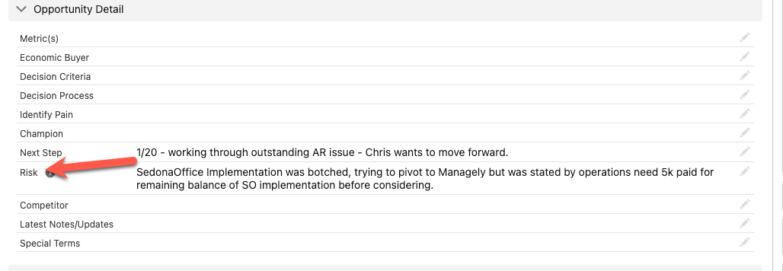
  - Change: New Name of Field: Risk Description

