SFDC – Add Primary Contact Role

Assigning Primary Contact Role to New Contact
- Select the drop down in the opportunity next to Contact Roles
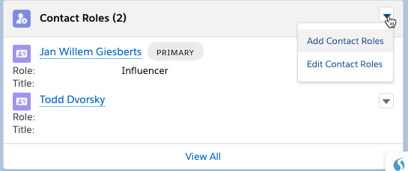
- Select the contact and click Next
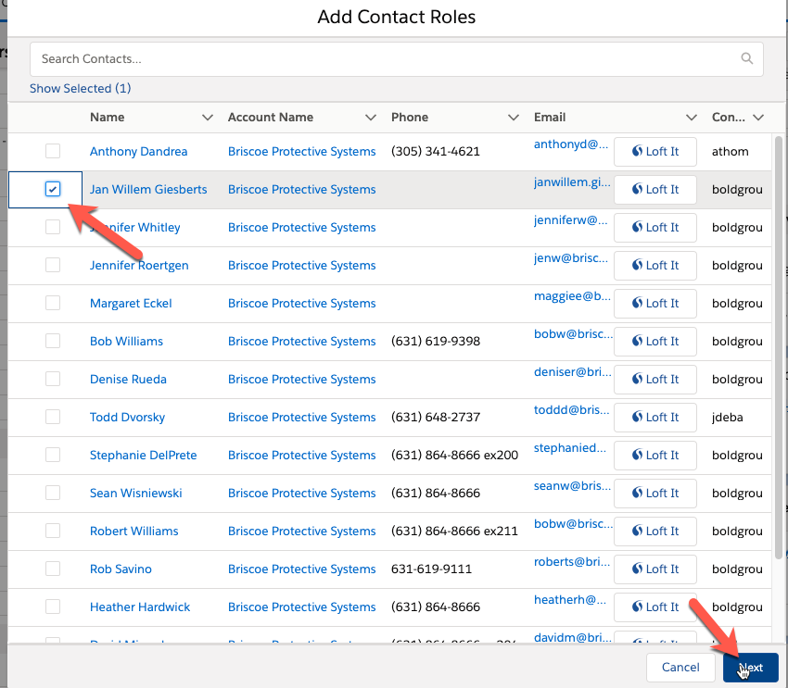
- Select a primary contact from the drop down
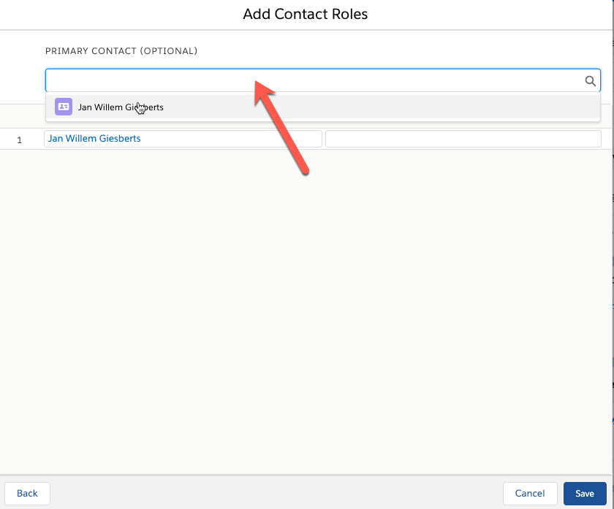
- Select the Role for the contact and select Save
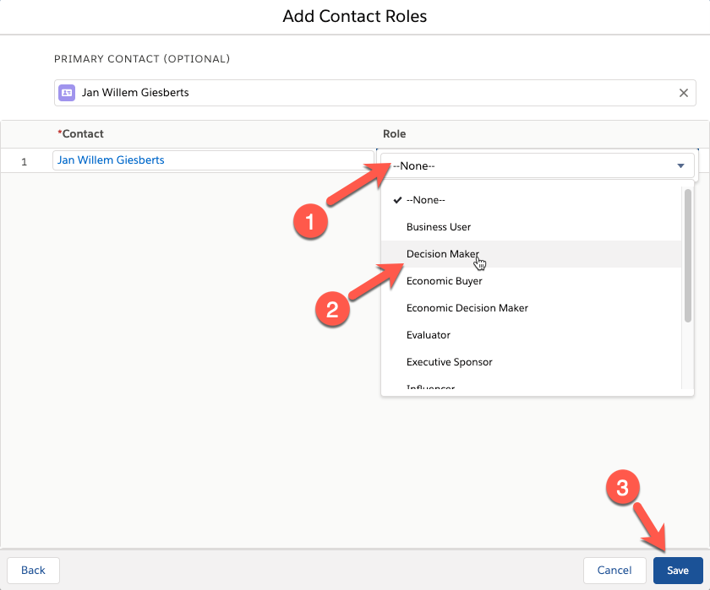

Assigning a contact role to an existing assigned contact
- Select the drop down next to the contact Edit Contact Roles
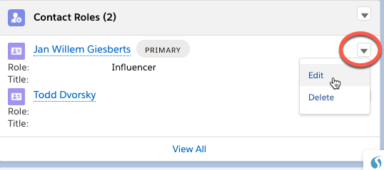
- Check the Primary check box and select Save
