Sedona Office On Prem (Standalone) Deployment
- Installing Sedona Office Server
- Pre Req’s : https://sedonaoffice.knowledgeowl.com/help/sedonaoffice-minimum-hardware-software-requirements
  - Visit https://sedonaofficeupdates.s3.us-west-2.amazonaws.com/iisstart.htm

  - Download the installation files needed for the customer deployment.
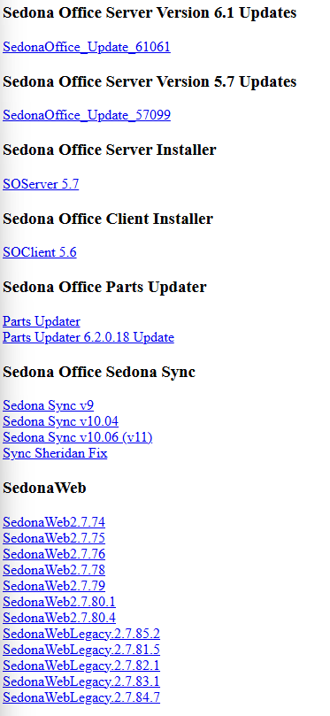
  - ** You will need the SedonaDay Code Application to apply patches for the new installations **
  - The order of installation from the base installer to the current version is important. The order is as follows:
    - Run Installer for SO Server 5.7
    - License the SedonaOffice Server installation
      - You will need the login into the SedonaOffice License tool 10.199.5.31, this server can be reached through the Mequon VPN in your OKTA portal
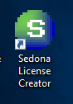
      - Enter in the Customer information in the tool alongside for the Program ID given to generate the License Key
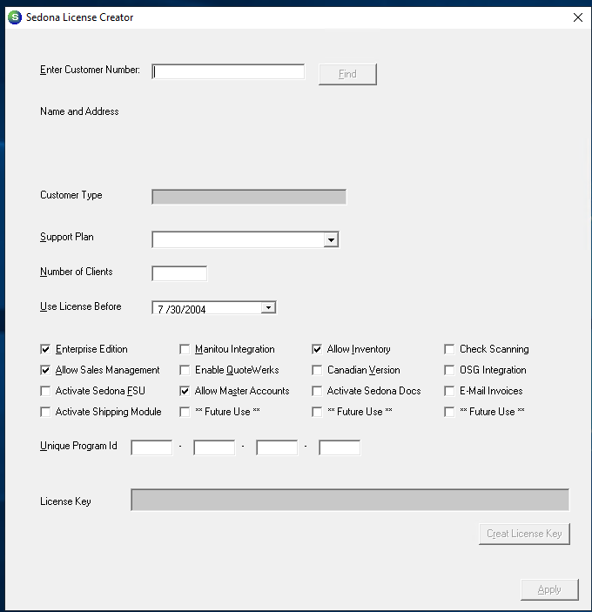
    - Run Installer for SO Client 5.6
    - Run Installer for SO Update 57099
    - Run Installer for SO Update 61061
    - Run Installer for SO Update (Latest version of 620XX)
  - Following the prompts for the installers and the following databases will be created
    - SedonaMaster
    - SedonaDocuments
    - MasterSetupStandard
  - To install the MasterSetup Tier 1 Database download the .bak file from the download center. Open SSMS and restore the database to the customer SQL instance.
  - If there is a custom customer database this will need to be done manually through SQL server import & export wizard or backup and restore in SSMS.
- The base setup is now complete for customer configuration please see: https://dyzz9obi78pm5.cloudfront.net/app/image/id/67ddcc738a20c838740baa93/n/sedonasetup-training-setup-guide-v5799-6x-1.pdf

