Setting Up a Company to Use SedonaEmail

Basic Setup
- Support ticket created for activation of SedonaEmail
  - Customer generated
  - Implementations Generated
  - Michelle sends them the getting started materials.
- Wait for first response from customer.
- Setup the Sub Account for the new company.
  - All SedonaEmail customers need to be attached to a sub-account. The subaccount name is not important, but it needs to be unique.
  - Add the sub-account in Mandrill
- Add the domain in Mandrill
- Generate the domain validation email
  - The customer needs to forward the email back
  - Click on the link to complete the process
  - Be sure that the target knows it is coming and what they need to do. Had a number of customers try to create a MailChimp account!
- Cycle through waiting for them to make changes to the DKIM and SPF until they get it right. You may need to send the error messages with information on what they are doing wrong and how to correct it.
- Once you have the three green checks in Mandrill, you can make the changes to their setup.
- Use the script to make the database changes as needed. Be sure to update all company databases that will use SedonaEmail with the correct information.

Look Out For
Company in conversions installs on a conversion database for testing and the go live database is not updated. Need to be sure to update the conversion company and the mastersetup company.
Some domains will not make the changes needed. These customers will always use the generic email address. You still need to setup a separate sub-account!

SQL Script

Declare @FromEmail NVarChar(100),
@FromName NVarChar(100),
@DefaultSubject NVarChar (100),
@SubAccount NVarChar(100)

/*
These lines will give you the existing settings
*/

Select * from EM_Setup
Select * from EM_Template
Select * from SY_AlternateAddress
Select * from SedonaMaster.dbo.Company

/*
************************************
Setting the values
************************************
Note:
In all cases, setting the entry to a blank does not change the existing value.
*/

Set @SubAccount = '' --Which sub account
Set @FromName = '' --Put your Person/Company Name From Info between the quotes
Set @FromEmail = '' --Default?
/* Put the email address of who the email comes from and who they will reply to.
If you enter Default, the system will use the NoReply address.

Note: There is currently only a single selection for both from and reply-to */

Set @DefaultSubject = '' --None?
-- If you enter None, subject will show as default subject:> Invoice #12345

If @FromEmail = 'Default' Set @FromEmail = 'NoReply@SecurityServicesBilling.Com'

If @DefaultSubject <> ''
Begin
If @DefaultSubject = 'None'
Set @DefaultSubject = 'Invoice #{{default_value}}'
Else
Set @DefaultSubject = @DefaultSubject + ' Invoice #{{default_value}}'
End

Update EM_Setup
Set Message_Text_Interval_Milliseconds = 0,
Account_Name = Case When @SubAccount = '' then EM.Account_Name else @SubAccount end
from EM_Setup EM

Update EM_Template
Set From_Email = Case When @FromEmail = '' then EM.From_Email Else @FromEmail end,
From_Name = Case When @FromName = '' then EM.From_Name Else @FromName End,
Reply_To_Email = Case When @FromEmail = '' then EM.From_Email Else @FromEmail end,
Default_Subject = Case When @DefaultSubject = '' then EM.Default_Subject Else @DefaultSubject End
From EM_Template EM
Where Name = 'Sedona Office Invoice Test'

https://login.mailchimp.com

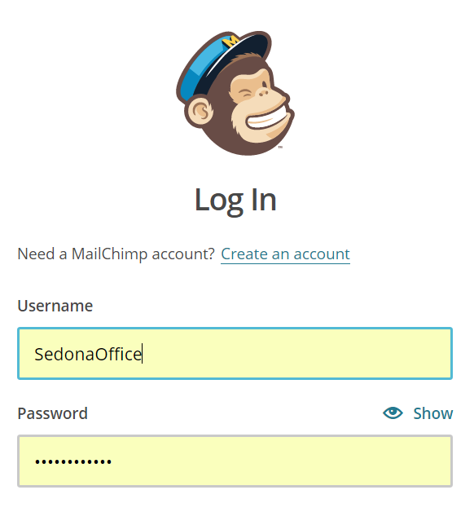
At time of production, pwd = Sed0n@office (Note: 0 is a zero)

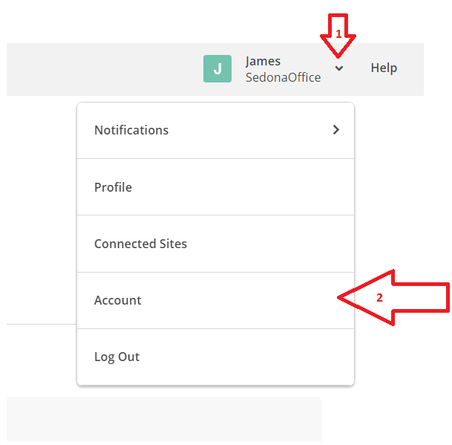

Click the drop down arrow (1) and then select- account (2).

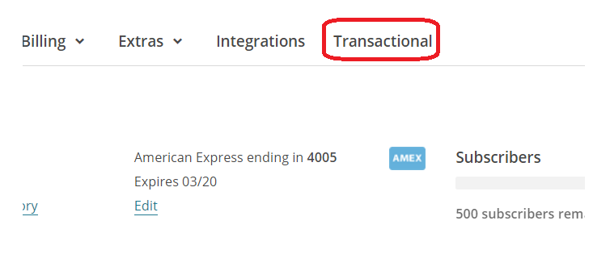
Choose Transactional.
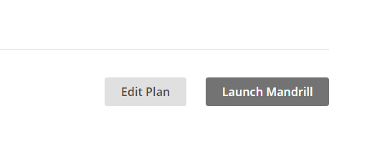
Click “Launch Mandrill”

This will take you to the Dashboard.

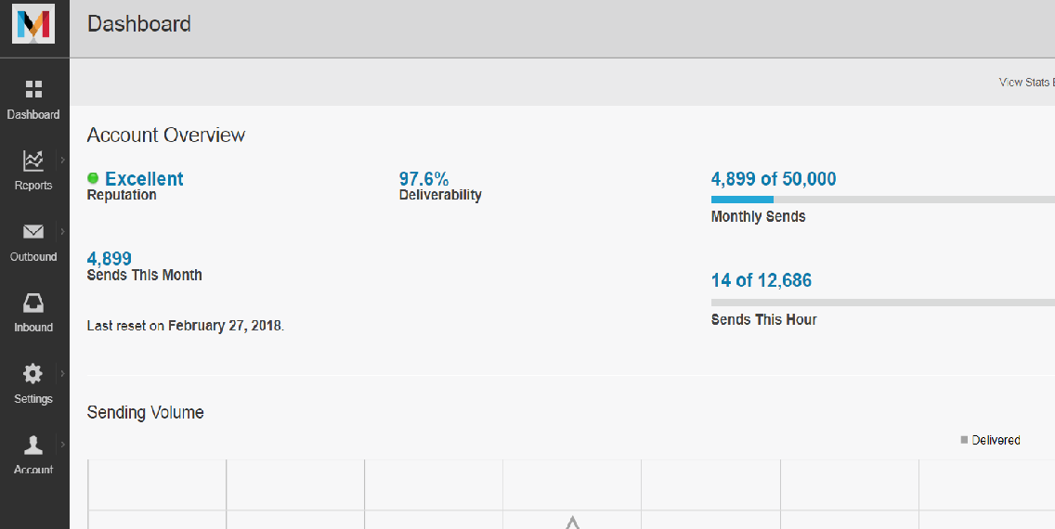

From the Dashboard you can manage the SedonaEmail accounts.

SubAccount Setup
Click Outbound
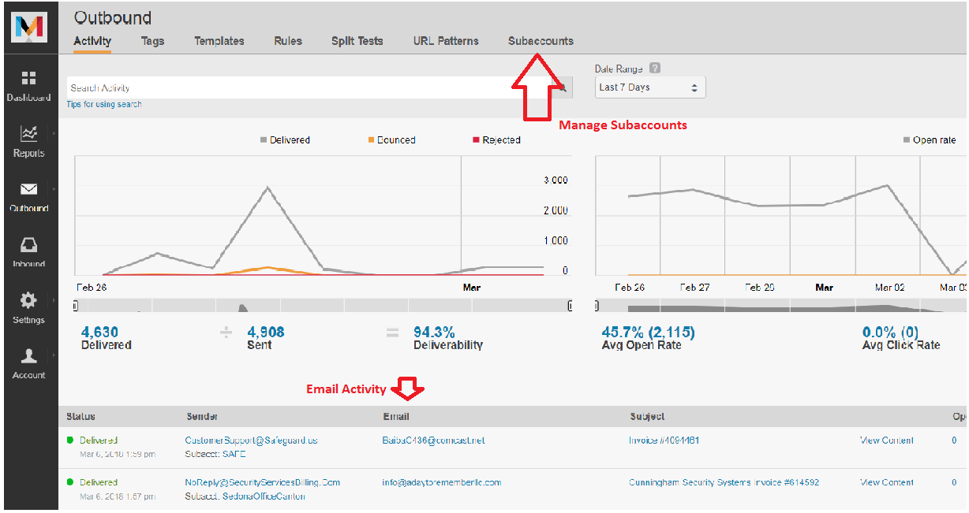
Click SubAccounts.
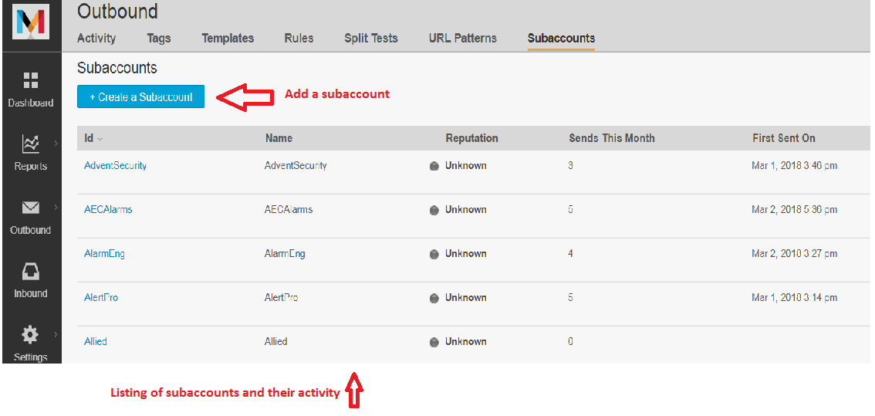
Click on Create a Subaccount.
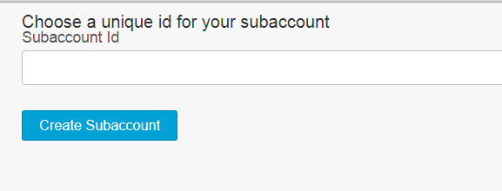
Enter the name of the new subaccount and click “Create SubAccount”
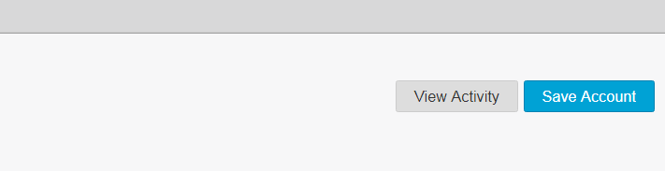
Click Save Account. The Subaccount will be created.

Domain Verification
From the Dashboard, click Settings.
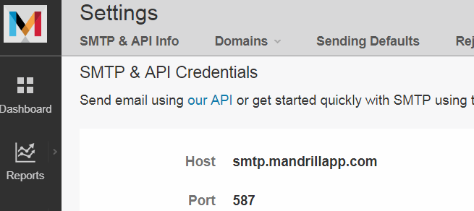
Click the Domains.
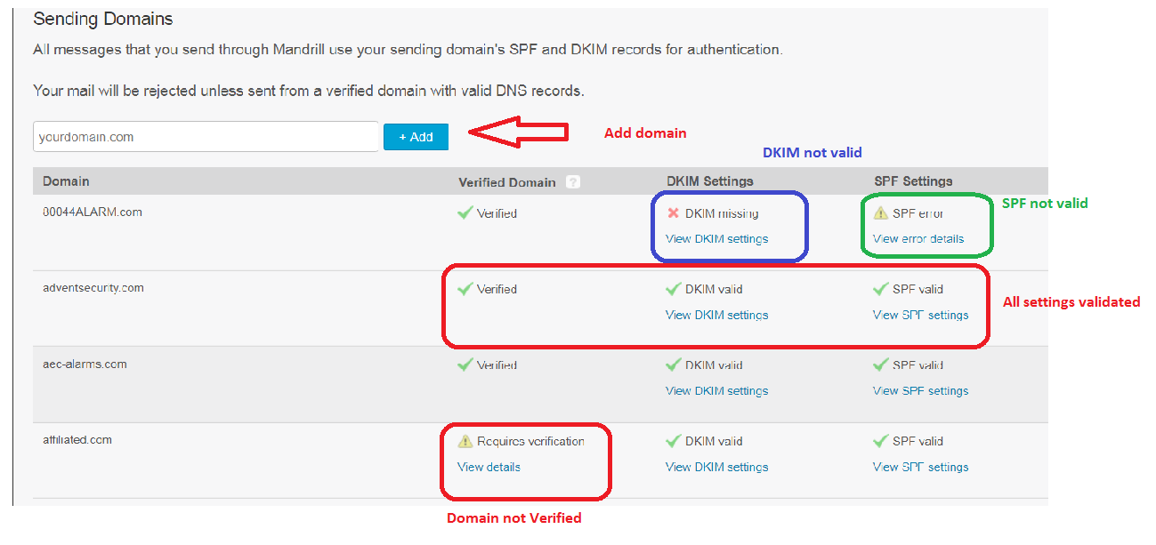
Add a domain by typing the name of the domain into the blank and click the “+ Add” button. If the domain is valid, it will be added to the list.
All three sections must pass testing for the Domain to be valid. Each item is verified separately, so they can do them all at the same time.

Verify Domain
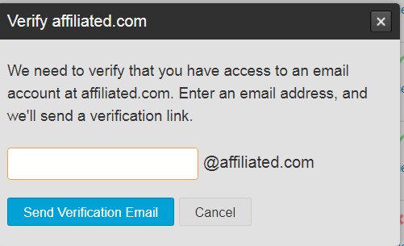
If you click on view details, you are presented with a data entry dialogue. Enter the email address of the individual you want the verification email sent to. Note: the @affiliated.com is already provided!
When you click “Send Verification Email”, Mandrill sends an email to this address. The target person needs to forward this email back to you. Once you get the email (from the forward), open the item and click on the link provided. (Note: you must be signed in to Mandrill or you will be prompted to sign in.) Mandrill will show the message “Domain Verified”.
For the DKIM and SPF settings, the procedure is the same. Click -
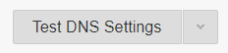
Mandrill will reach out to the DNS server to inspect the items. If they pass, the entry will receive a green check mark. If there is an issue, a red X displays. You can click “View DKIM Settings” or “View SPF Settings” for a description of the problem and a suggestion for addressing. After the user has followed the suggestions, click again to see if the changes were successful. Once all three green check marks appear, the domain is validated.

