Octopus and SedonaCloud Installation
**FOR CLOUD CUSTOMERS**: you can start with cloning the project in octopus (page 3) and finish with DNS and the API app pool settings.

Octopus Tentacle Install:
Download tentacle from octopus.com/downloads and install (just click next). Do this on the web server.
Tentacle Manager will open once installed to configure the tentacle:
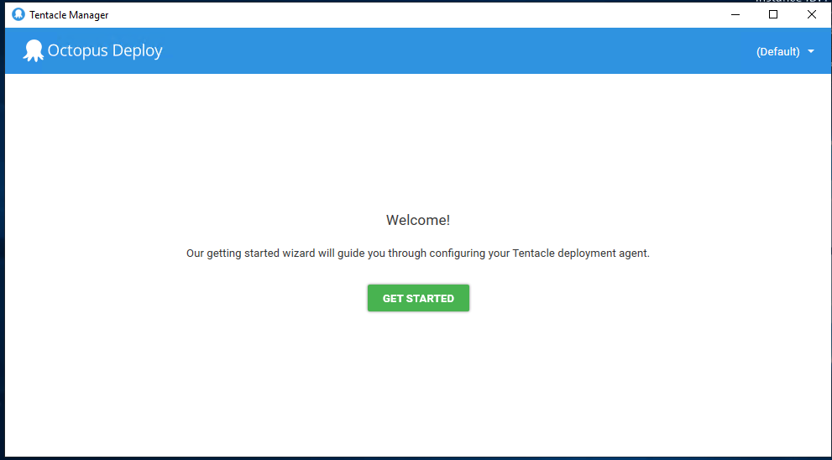
Click “Get Started” and then select “Polling Tentacle”:
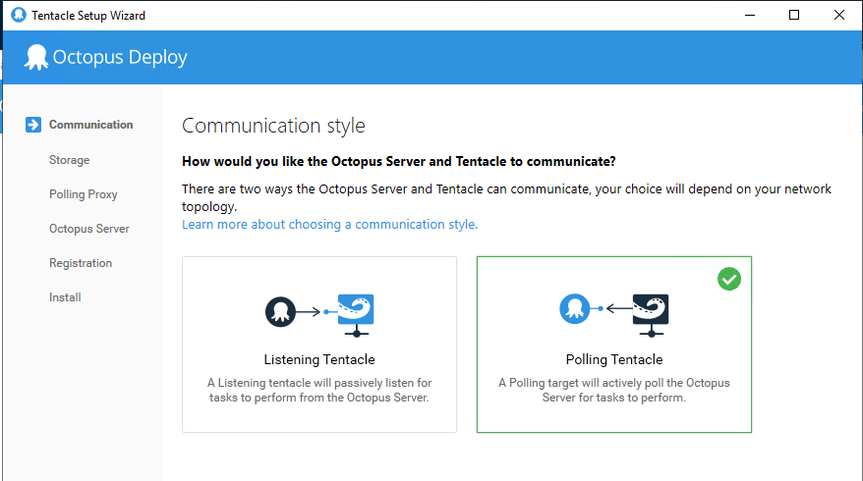
Click Next until on the Octopus Server/Credentials screen:
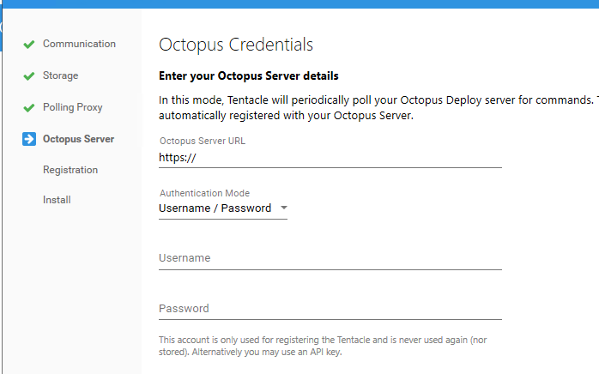

Use your Octopus credentials. Put http://alarmbillerdeployment.perennialsoftware.com:8080/octopus for the Octopus Server URL.
When you click next, it will validate the credentials entered.
On Machine Type, select the default Deployment Target and click next.
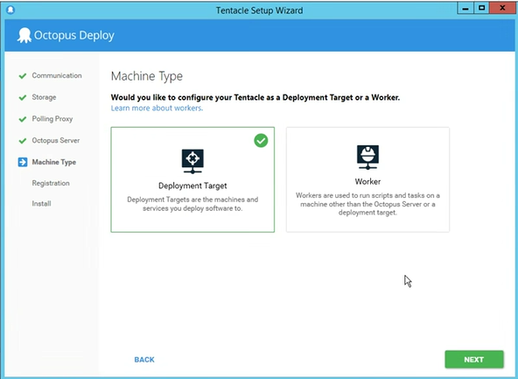
Now you register the machine with an Octopus environment and role. Select Default from the Space dropdown.
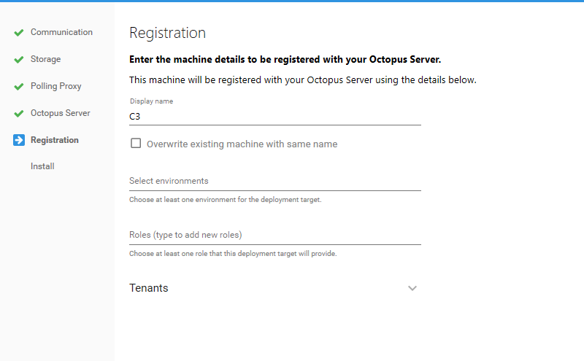
For display name:
Keep the default (the servername)
For environment:
SedonaAPI = API 1.0
SedonaCloud = API 2.0
For role:
Give it an identifiable role name. This is used later to identify the deployment target. If the company already has a role (from an API 1.0 deployment), typically we add SC for SedonaCloud (e.g. CustomerSC).

SedonaCloud Install:
Access http://alarmbillerdeployment.perennialsoftware.com:8080/octopus in a browser with same credentials used to set up tentacle in a browser.
Find it’s easier to find deployment projects by selecting “Projects” tab:
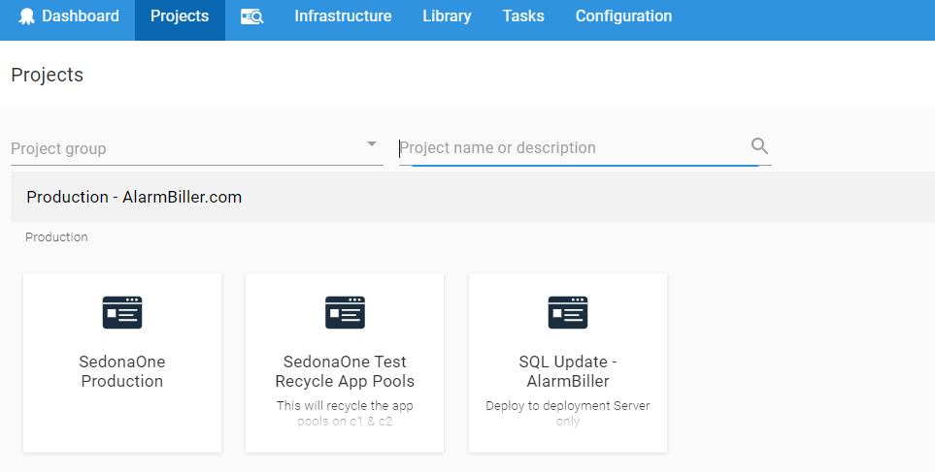
To start we will be cloning another Project. In the Project Group search, select SedonaCloud. Under the Project Name search, type Template to pull up the three templates we need for cloning.
Template Enterprise for Enterprise customers. Template AWS for AWS customers.
After selecting the project to clone, go to settings:
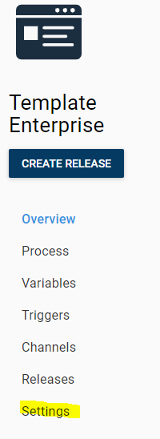
Click the 3 dots next to “Save” and select “Clone”:
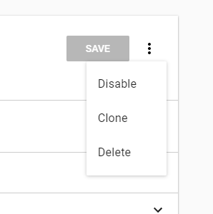
Name the new project (typically ‘Customer Name’, but ‘Customer Name SedonaCloud’ if upgrading from API 1.0) and click save.
Now you will be editing the newly cloned project.

Process:
Select Process on the left and you should see a “Deploy to Template” process. Delete any duplicate processes that you see before continuing:
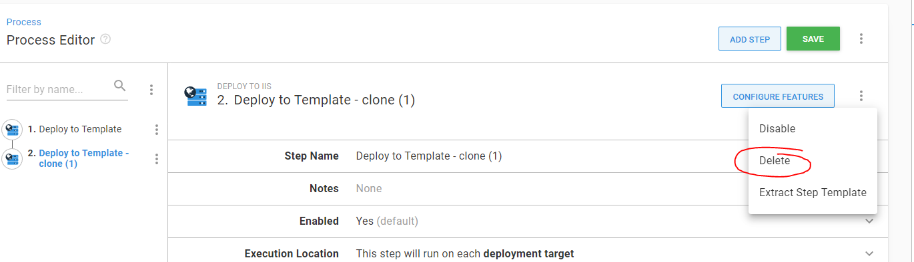
Navigate into the “Deploy to Template” process. Rename it to “Deploy to CustomerName” under Step Name. You should now see where you’re configuring the IIS settings within Octopus:
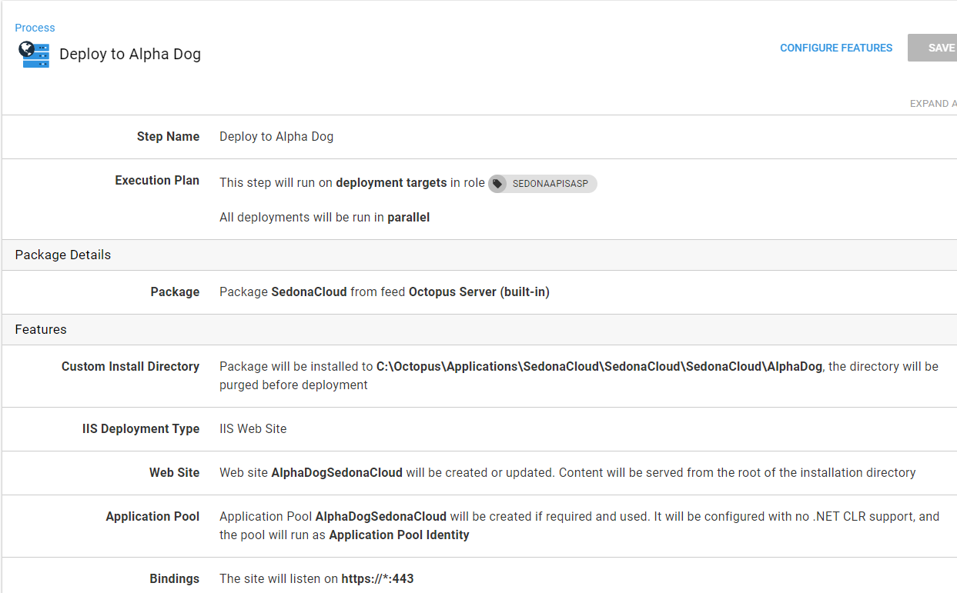
For Enterprise or Dedicated Cloud customers: Next to “Execution Plan” click the x on the role (hover over it to get the x) and then enter the role you gave the Octopus tentacle.
For Cloud Customers: Verify the role says “SEDONAAPIAWS”
For all customers: Verify the Package says “from feed Octopus Server (built-in)”
For Cloud Customers: You should have a “Custom Install Directory” line. If you do not, click on Configure Features at the top to add:
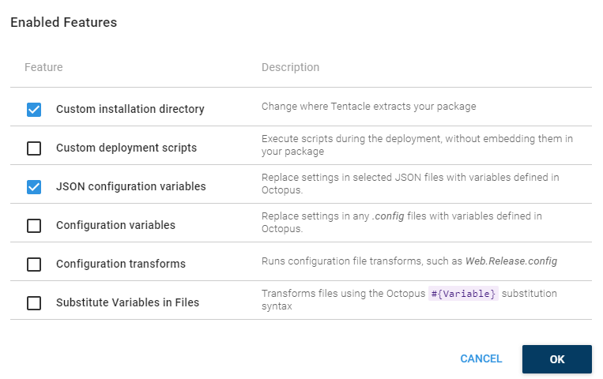
The install path should look like this: C:\Octopus\Applications\SedonaCloud\SedonaCloud\SedonaCloud\CustomerName
Enterprise customers should not have the “Custom Install Directory” line unless they need to have multiple API 2.0 endpoints on one server for some reason. One endpoint can serve multiple companies out of the same SedonaMaster, so this should almost never be needed.
If using a custom install path, make sure the checkbox for “Purge this directory before installation” is checked.
For Cloud customers: Make sure Web Site and ApplicationPool are named CompanyNameSedonaCloud. For Enterprise customers: Website can stay as just SedonaCloud.
For Application Pool:
The best way to set this up is running under the default “Application Pool Identity” for the Identity.
Older deployments may be using a local user that was granted SQL access for the Identity here. Moving forward, it’s easier to maintain (no PW to expire) to use the default and make some changes noted later in the process.
Bindings:
For enterprise refer to the preinstall and/or the placeholder site they should have created to verify DNS. Usually something like SedonaAPI.theirdomain.com:443
For cloud: You should only need to change the host URL, but also verify the SSL thumbprint is the latest SedonaASP cert. Delete any old ones there if they exist.
Once all of that is done, click Save.

Variables:
Select Variables on the left
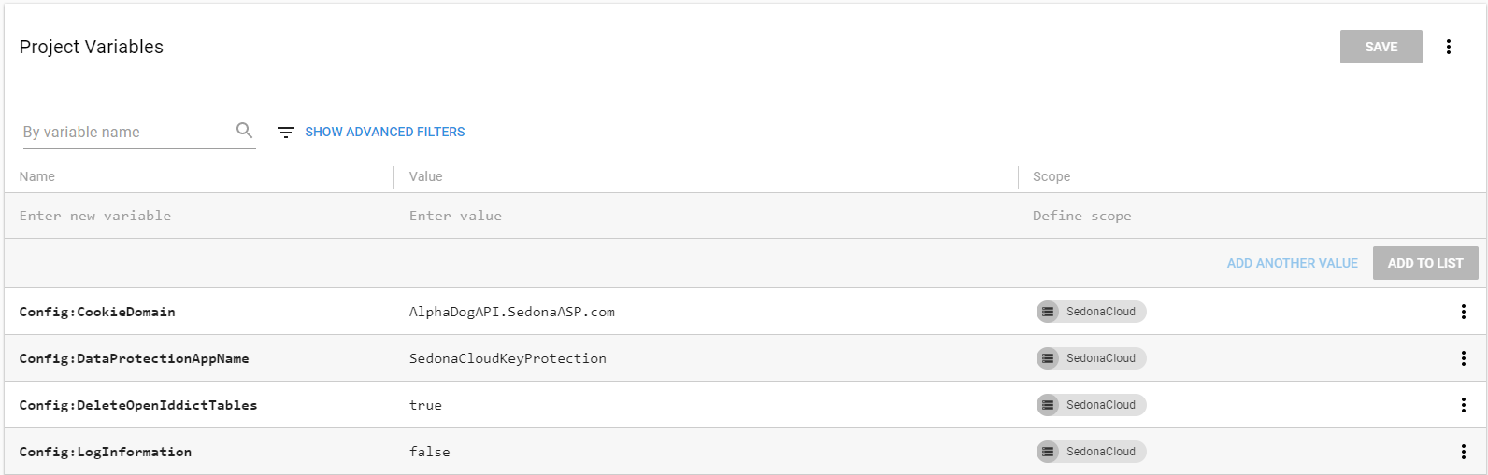
Config:CookieDomain – this is the URL without https:// preceding
Config:SedonaCloudClientSecret – generate a GUID (tick the “upper case” box and then generate): https://www.guidgenerator.com/. Copy this to this field.
Config:UseSubdomains – Verify this is included. Typically this will be set to “false” now unless the customer wants to use a wildcard SSL cert only for the API and use subdomain endpoints.
ConnectionStrings:DistributedCache – For all customers: This is for the API database (named SedonaCloud). For cloud customers in AWS the server is their named instance (can be found in SalesForce > Server Information for the customer > SQL Server Version eg. SQLAWS1\ExampleSQL). For enterprise customers, the server name will need to be verified either from preinstall or connecting during the install.
ConnetionStrings:SedonaCloudContext – See above.
ConnectionStrings:SedonaDocumentContext – This is the connectionstring to the SedonaDocs DB. For enterprise this is typically their SQL server, but they may have a separate Docs server. This should be noted on the preinstall. For cloud customers this is the named instance in AWS.
ConnectionStrings:SedonaMasterContext – This is the connectionstring to the SedonaMaster database. This will be the customer’s SQL server for enterprise or app server for cloud.
ConnectionStrings:SedonaOfficeContext – Connectionstring for the company database. Cloud customers the named instance in AWS.
ConnectionStrings:TempData – as with ConnectionStrings:DistributedCache
License – See LastPass for the link, signature, and keys. On the license generator site:
ExpiryDate: set to year 9999
Name: Customer company name
Email: email on ticket
Max Company: 100
SedonaWeb: Check customer systems in SedonaOffice or on the project . Check/uncheck accordingly
Sedona-X: Check project info or customer systems/licenses in SF. Check/uncheck and set user count accordingly.
Click create and copy the generated license into the Octopus Project
LicensePublicKey – Should remain the same, but also in the License generator LastPass note
Urls:IdentityServerUrl and Urls:url – this should be the full host URL including https:// and the port if not using standard 443 (e.g. if an ent customer wants to use port 4443: https://exampleapi.customerdomain.com:4443)
After entering all of that, click “Save”. Now we are ready to package everything as a release and deploy.

Release and Deploy:
Select Releases from the lefthand menu
Click create release:
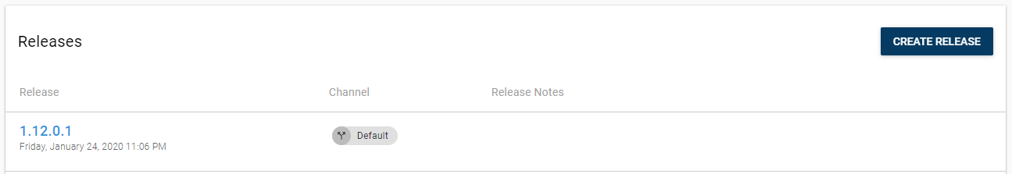
Here we make sure to select the search radio button under Packages to ensure it’s not a pre-release build (there’s a checkbox to hide pre-release builds; they will also have –pre-QA after the build number) and make the Version # match the package version #. Confirm the version of SedonaCloud to deploy based on the customer’s version of SedonaOffice and the compatibility matrix updated by development: Product Releases and Product Matrix Compatibility | Internal KB
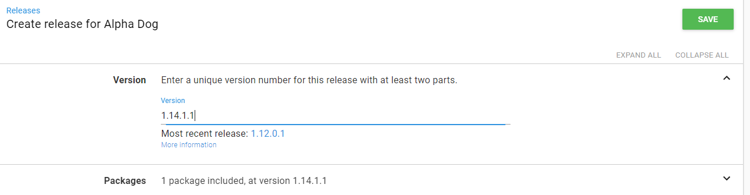
Note: If you need to change something in the process or variables and re-release the same version (troubleshooting, SSL cert update, etc.), you will need to make a new release with a new version number. You can use a hyphen to add a note to the end of the version name for what you changed. E.g. 1.14.1.1-SSLthumbprint. This is intended for naming beta builds, but it works better than incrementing the actual build number in cases where we need to redeploy to fix a config mistake or expired SSL/PW.
Click “save”. Then “Deploy to” and select SedonaCloud.
If all goes well, in 1-2 minutes you’ll have the new API endpoint deployed.

IIS Settings Updates:
Connect to the hosted API server. You can use remote desktop on the Mequon VPN from your OKTA to connect to 172.31.25.183
In IIS Manager (Start > Windows Adminitrative Tools > Internet Information Services (IIS) Manager), go to Application Pools and select the SedonaCloud Application Pool (or CustomerNameSedonaCloud if a cloud customer).
Advanced Settings
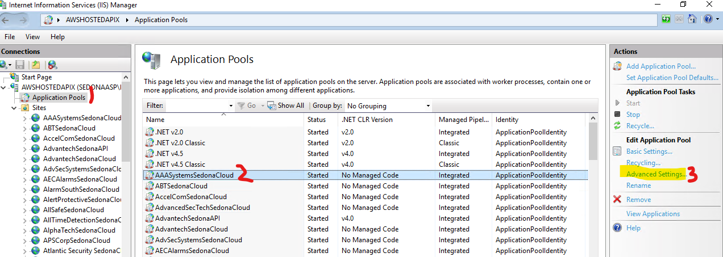
- Change “Load User Profile” to True.
- Change “Start Mode” to AlwaysRunning
- Change “Idle Time-out (minutes)” to 0
- Change “Regular Time Interval (minutes)” to 0
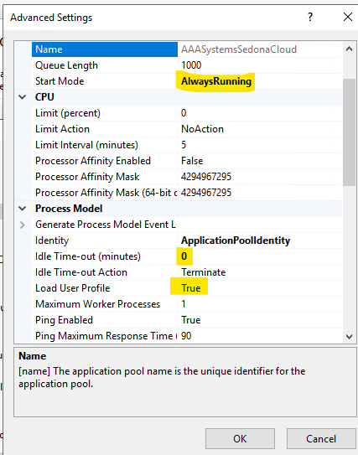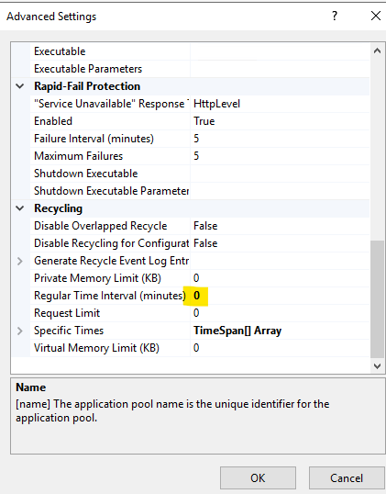

Go to C:\Octopus\Applications and open the Properties for the SedonaCloud folder. Make sure IIS_IUSRS has full permission to the folder.
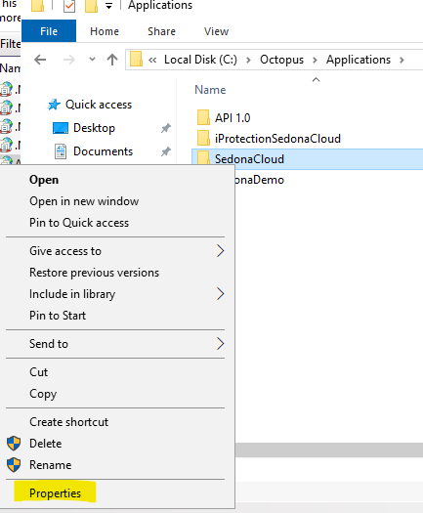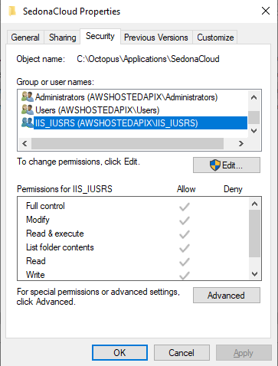
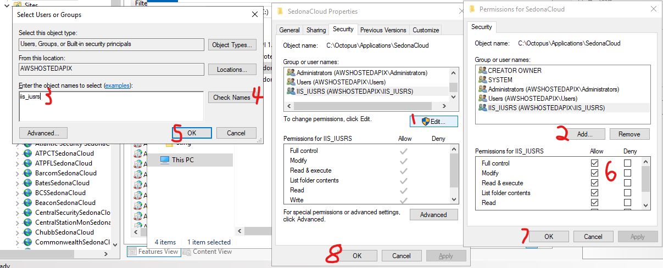
Test by browsing to the URL in a browser.
If this does not work, make sure to check the hosts file and add an entry as needed:
127.0.0.1 customerurl.customerdomain.com
(local) and their (host url)

Additional Steps for Hosted Customers:
Create infrastructure case to create DNS records and whitelisting for the API URL. Make sure to list the API URL and note that it is a hosted API in the case.
Infra checklist:
Cloudflare DNS
API server host file – Also needs Customer TSP
SedonaASP Domain DNS
SQL Instance Firewall

Adding Initial Company DB to API
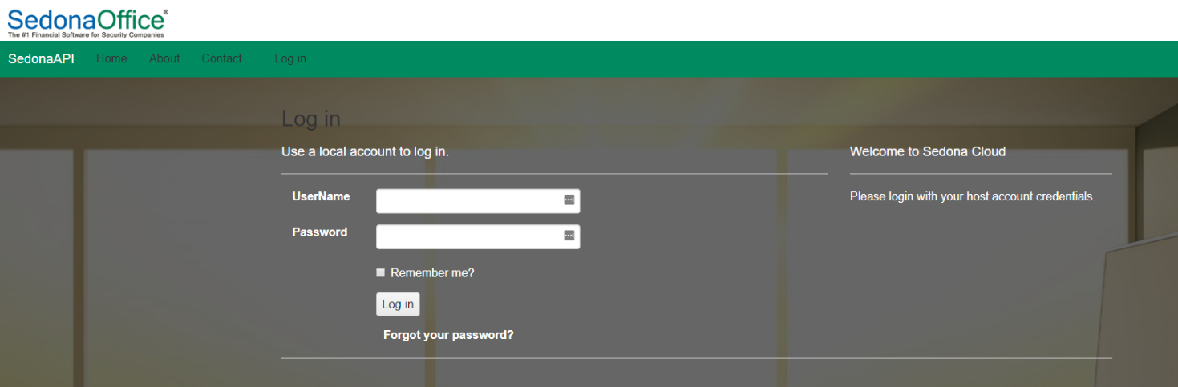
Select Company from the top menu, then Add Company:
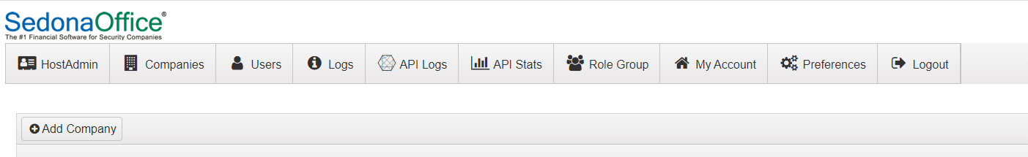
Make sure the company list is populating from SedonaMaster.
- Add the company
  - Add the UrlPrefix
  - Company Email
  - User Name CompanyAdmin
  - User Name Email
  - Password: any PW you can document in LP for internal and provide to customer
That’s it! Provide the customer the host login, URL, SedonaCloud documentation link or pdf, the ClientSecret you configured and the ClientId which is always SedonaCloudClient.
Ex.
https://service.alarmcoinc.com
Prefix: final
User: Customeradmin
Pw: Thisisapassword123!

If the Customer has SedonaWeb or Sedona-X, provide the company URL configured above for them to direct customers to (SW) or add in the Sedona-X mobile app (Sedona-X), as well as the company admin credentials for them to manage company preference (e.g. https://customerurl.customerdomain.com/companyprefix)

Common install issues:
If Tentacle doesn’t install- make sure user account is not a guest account
For the method described above using the default app pool identity, SedonaUser will need at least dbcreator access. If this is not the case, it’s easy to diagnose even if not on the SQL server as there will be a Windows event log for the site failing to load that will reference SQL if you look in Event Viewer. If you see that, you know you need to get access to SQL to at least temporarily elevate SedonaUser.
It’s also really easy to forget to change “Load User Profile” to true in the advanced app pool settings.
Otherwise usually it only fails to start if there is either a missing pre-req or the server is not resolving the URL from the Octopus variables to itself. Remember if not using port 443, the Urls: variables need to include the port.
If the SedonaCloud DB isn’t being created- check the .net core hosting and Redis are installed.
https://dotnet.microsoft.com/en-us/download/dotnet/thank-you/runtime-aspnetcore-2.1.30-windows-hosting-bundle-installer
https://github.com/MicrosoftArchive/redis/releases/download/win-3.2.100/Redis-x64-3.2.100.msi

