Hosted Customer Cancellation Procedure
Note: This includes enterprise customers who pay for the SedonaBackup service and/or hosted SedonaWeb Legacy
Infrastructure to receive a case with cancellation details in the Infrastructure queue. Needed details: Customer Name Product(s) cancelled (e.g. Hosted SedonaOffice, hosted SedonaWeb/API/Sync, AB, Managely) Effective Date Dealer # (if cancelling AB or Managely)

Infrastructure Procedure for Cancelled Customers

SedonaOffice Hosted
EC2 Instances
Login to AWS (https://aws.amazon.com/console) and go into EC2. Find the customer's TSPlus instance (or dedicated environment instances). Select the instance(s) to remove > Instance State > Terminate Instance. Confirm termination of instance.
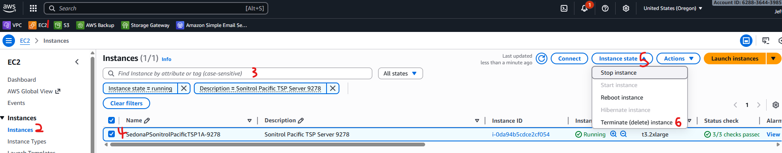

Target Groups and Load Balancer Listeners
In AWS EC2, navigate to Target Groups. Find the Target Groups for the customer - there should always be a TSPlus and RDP Target Group and there may be one or more HTTPS, WeSuite, or OPTWS labelled Target Groups. Select one of the target groups and note the Load Balancer displayed in the Target Group details. If there are any HTTPS, WeSuite/WS, or OPTWS Target Groups, check each and note the Load Balancers if different. Then select the Target Groups to delete > Actions > Delete. Confirm by clicking Delete.
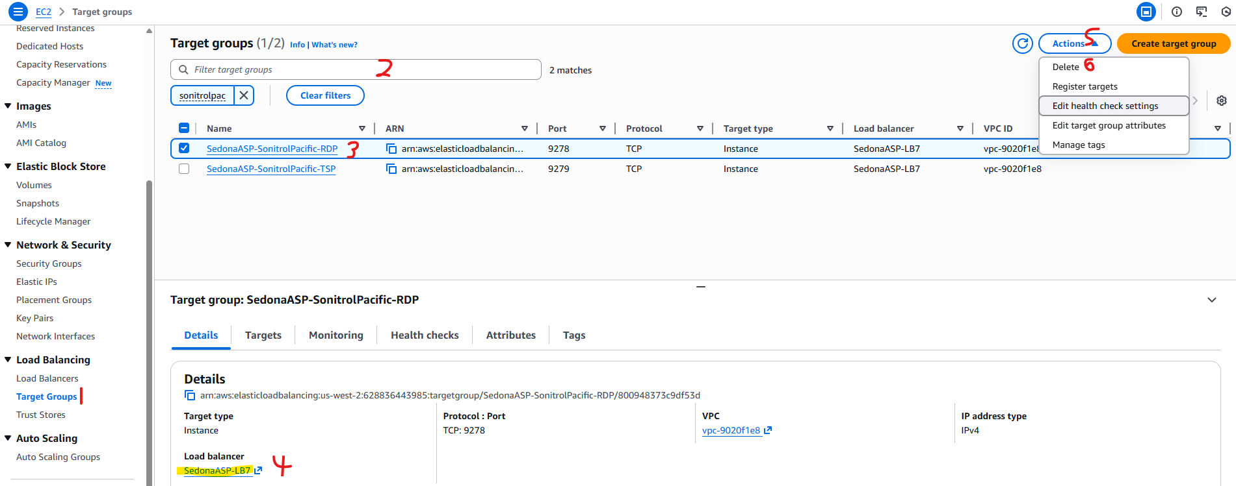
Navigate to Load Balancers and select the Load Balancer noted previously. Under the Listeners tab (default), find the Listeners associated with the Target Groups and select them. Actions > Delete listener. Type confirm and click delete to confirm.
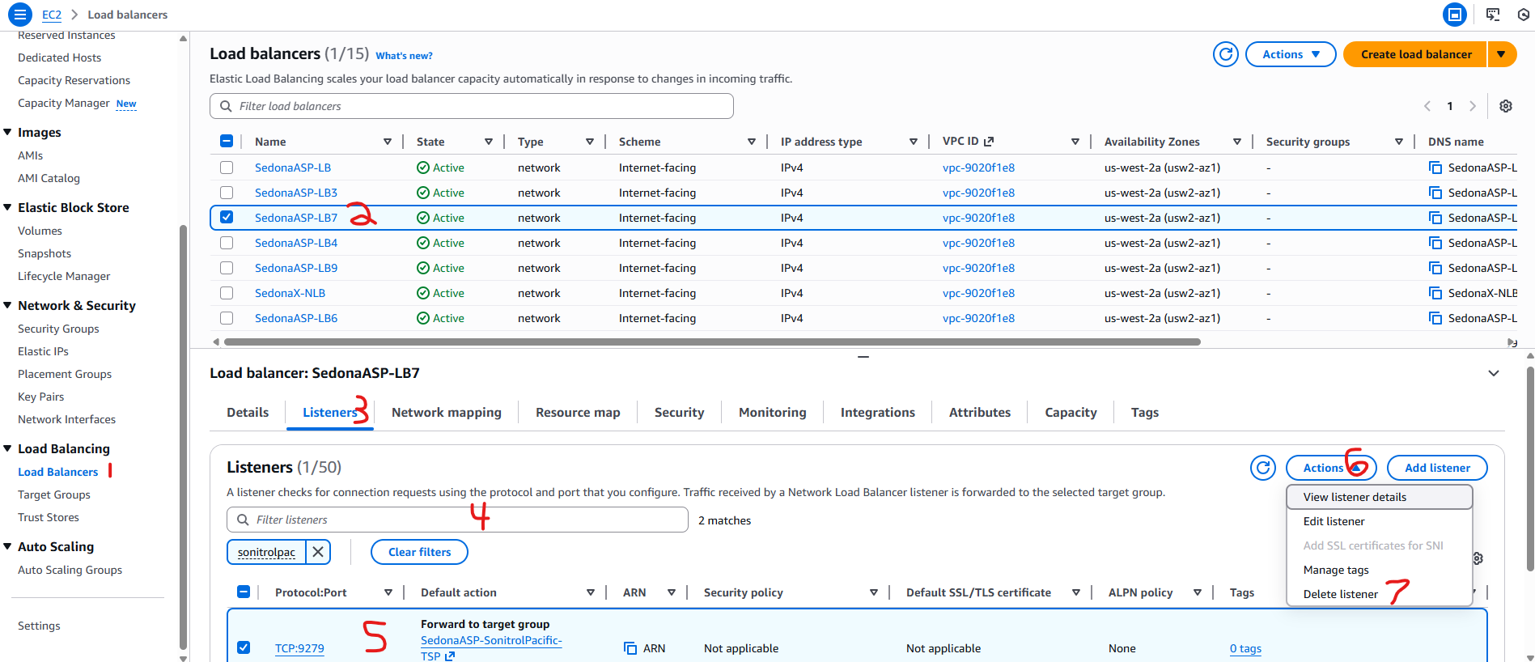
Note the IP for each Load Balancer associated with the cancelled customer by navigating to the Network Mapping tab and noting the IPv4 IP following "Use an EIP:"
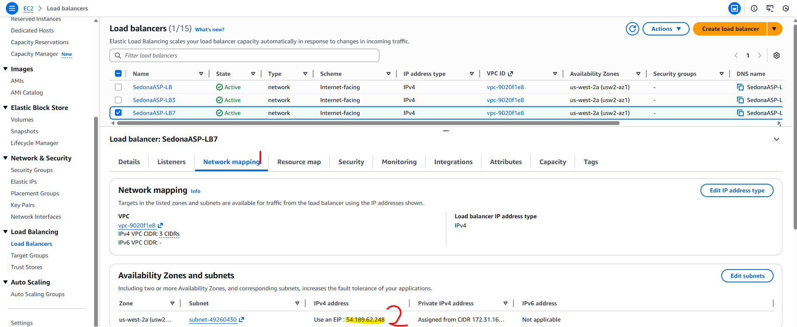

Cloudflare DNS
Login to Cloudflare (https://dash.cloudflare.com) and under the BoldGroup account navigate to SedonaASP.com > DNS.
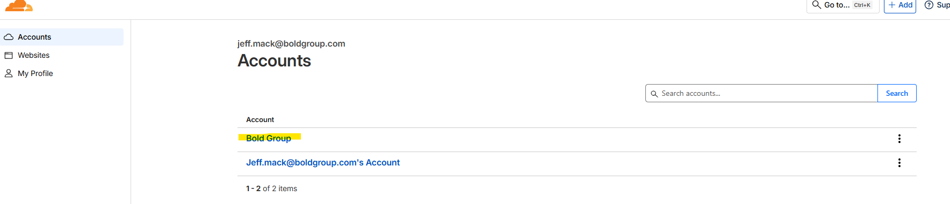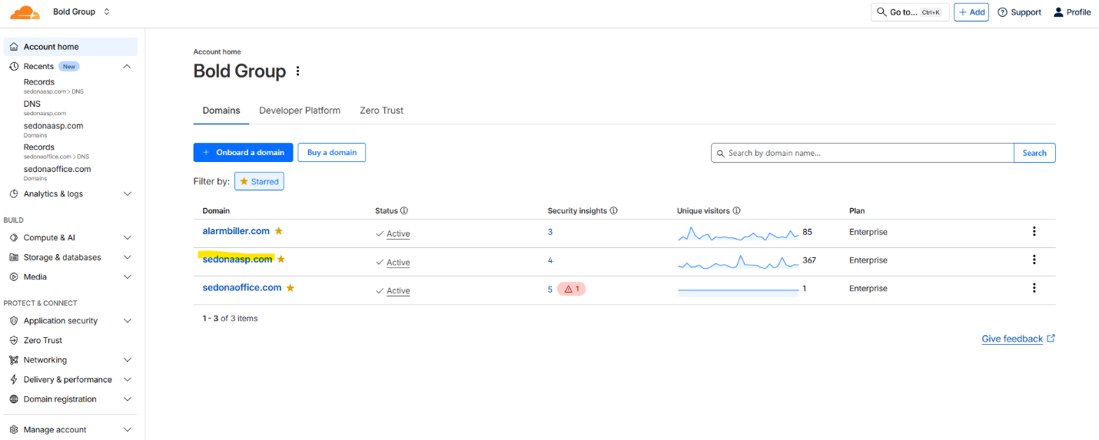
Find and select the DNS records for the customer using the IP of the Load Balancer(s) noted above and customer name in the record or comment. Click the "Delete x Records" button above the list. Type DELETE and click "Delete" to confirm. For communal customers, also check for records pointing to 54.214.143.35 (SedonaAPI server), 44.233.75.66 (SedonaWeb Legacy), 54.214.253.119 (WeSuite hosted), and/or 52.37.214.20 (OPTWS hosted) if applicable and delete those as above.
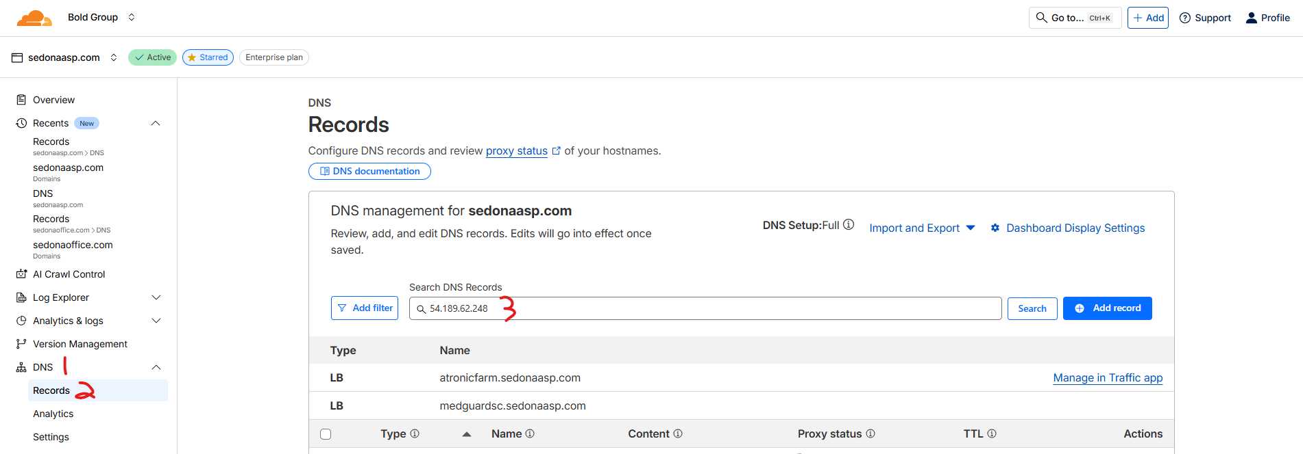
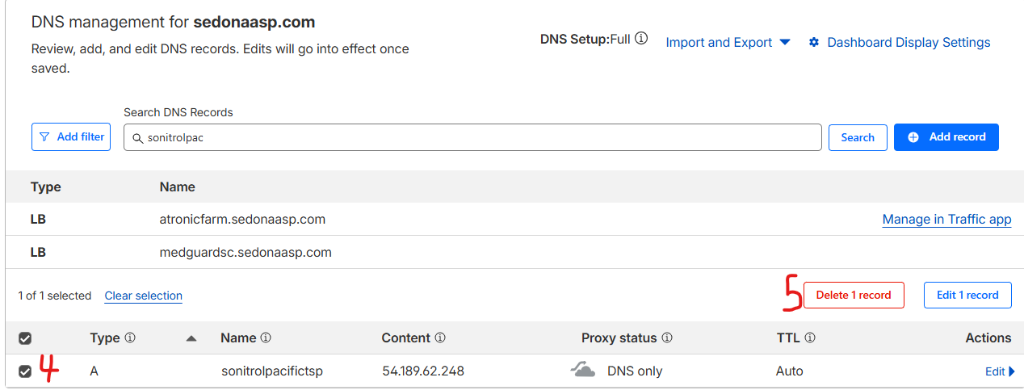

Active Directory and Duo
Login to the SedonaASP domain controller (IP 172.31.20.209 in Teleport). Launch Active Directory Users and Computers. Find the customer's OU in Active Directory (select older customers may not be under their own OU). Right-click and delete the customer's OU. Confirm removal of the OU.
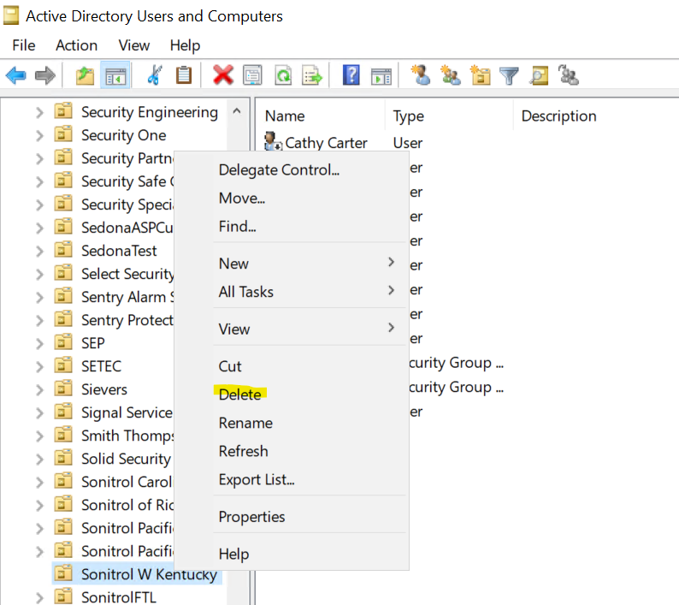
Under computers, find their TSPlus instance name, right-click, and Delete it. Confirm the deletion of the AD Computer account.
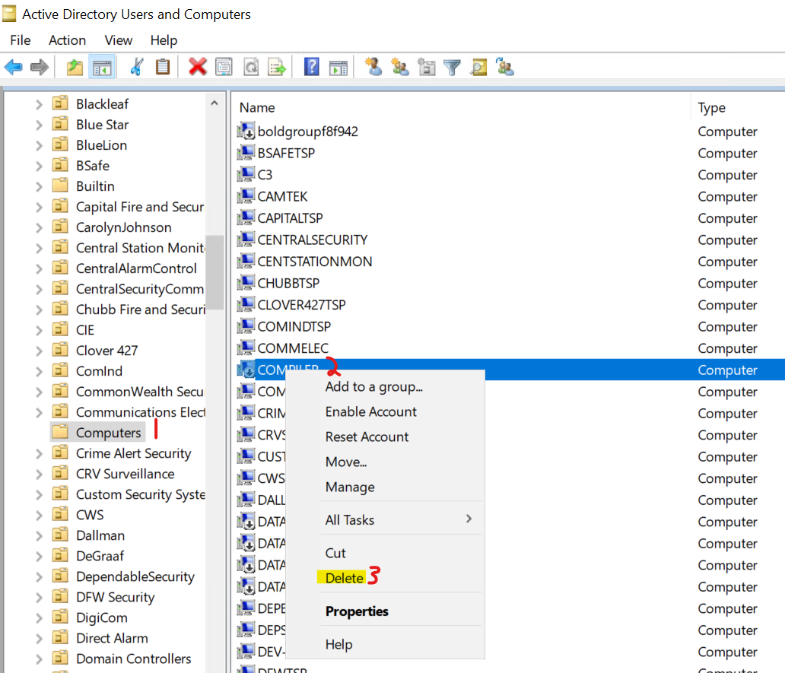
Login to the Duo Admin portal (https://admin.duosecurity.com). Go to Users > External Directories (under Configure heading).
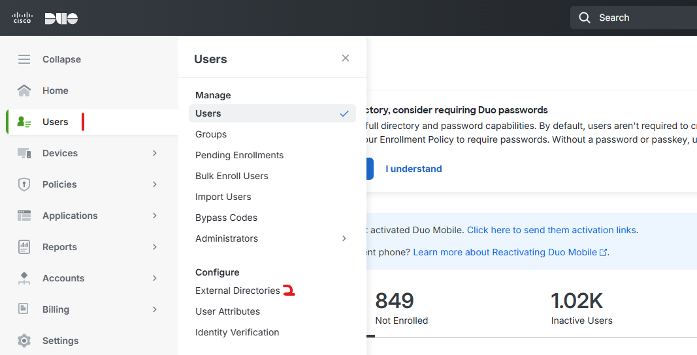Click SedonaASP.com.
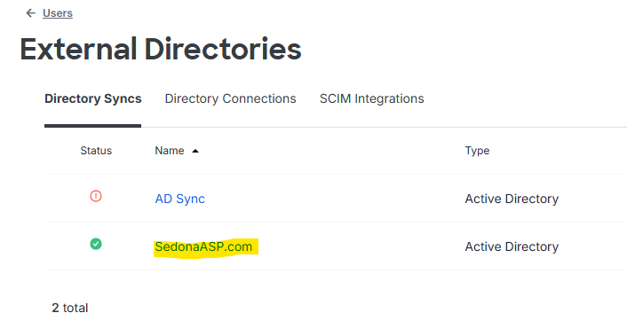Find the Groups section. Click on the X next to the customer's Duo Group. Then click the Save button in the top right corner.
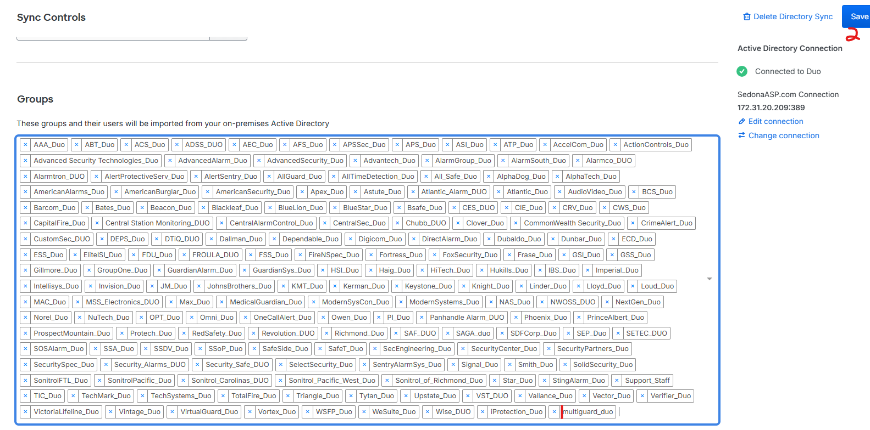
Then scroll back up and click on the Sync Now button.
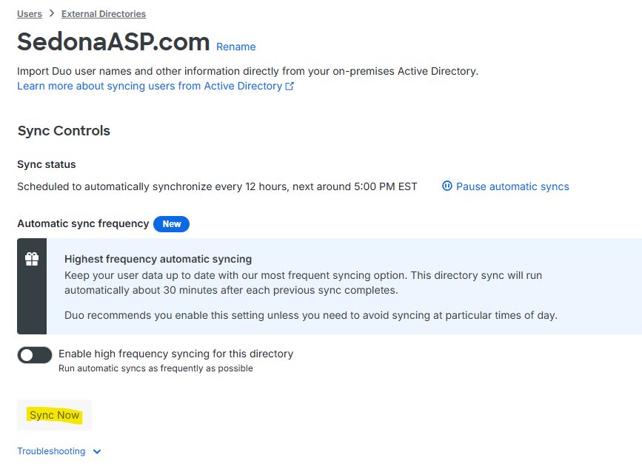
Navigate to Users > Users.
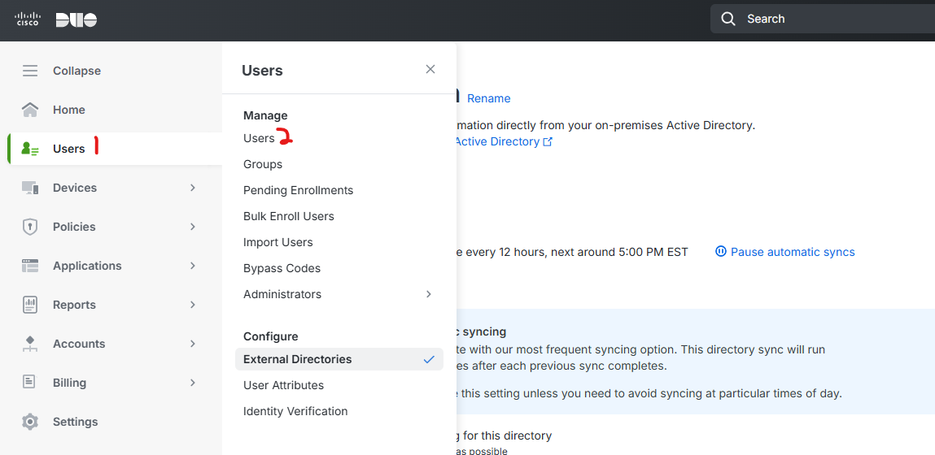
Check the Trash tab. Users from the removed AD groups should be marked for deletion here. Select them and then click the "..." button > Permanently Delete. Confirm by clicking the "Permanently Delete" button.
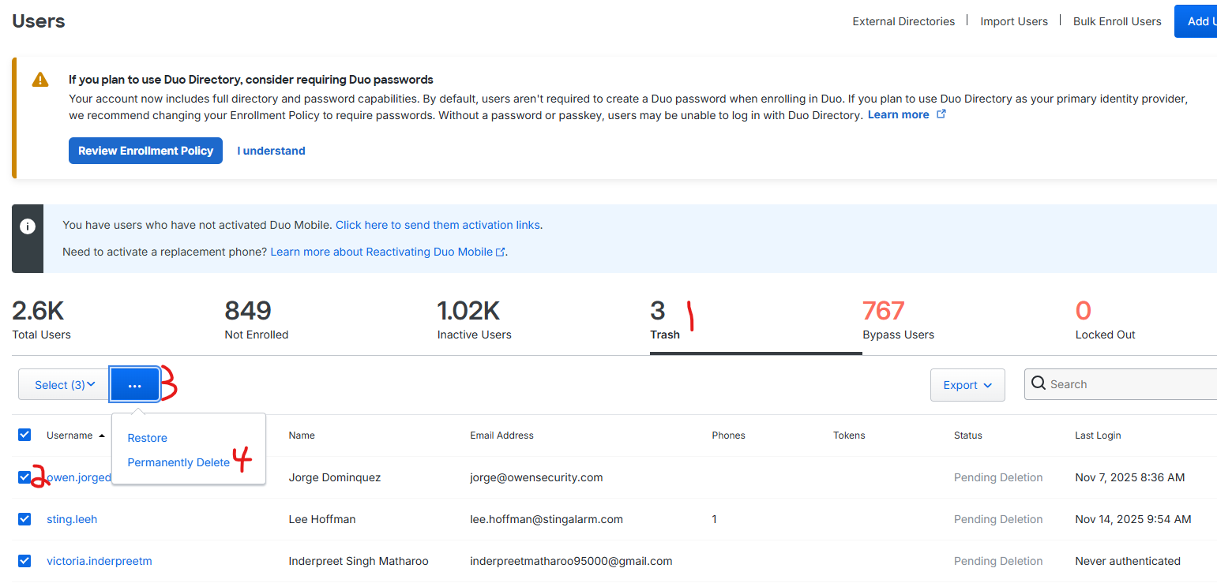

SQL Instance and MSP360
In Salesforce, locate the customer's SQL instance under their server info > Hosted SedonaOffice > SQL version.
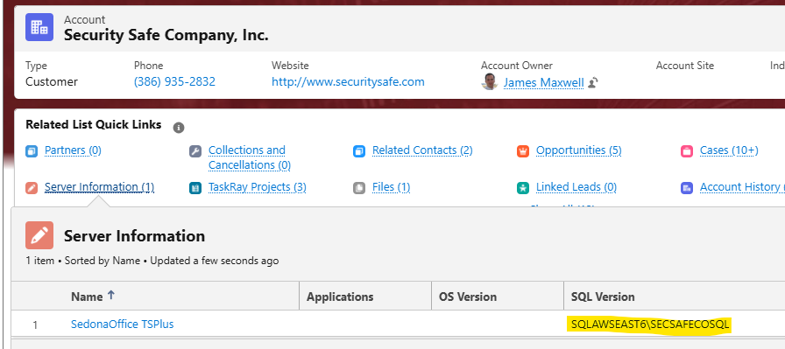
Login to the SQL server indicated by this information. Go to Control Panel > Programs and Features. Locate and select Microsoft SQL Server #### (where #### is the year/version of SQL). Click "Uninstall/Change".
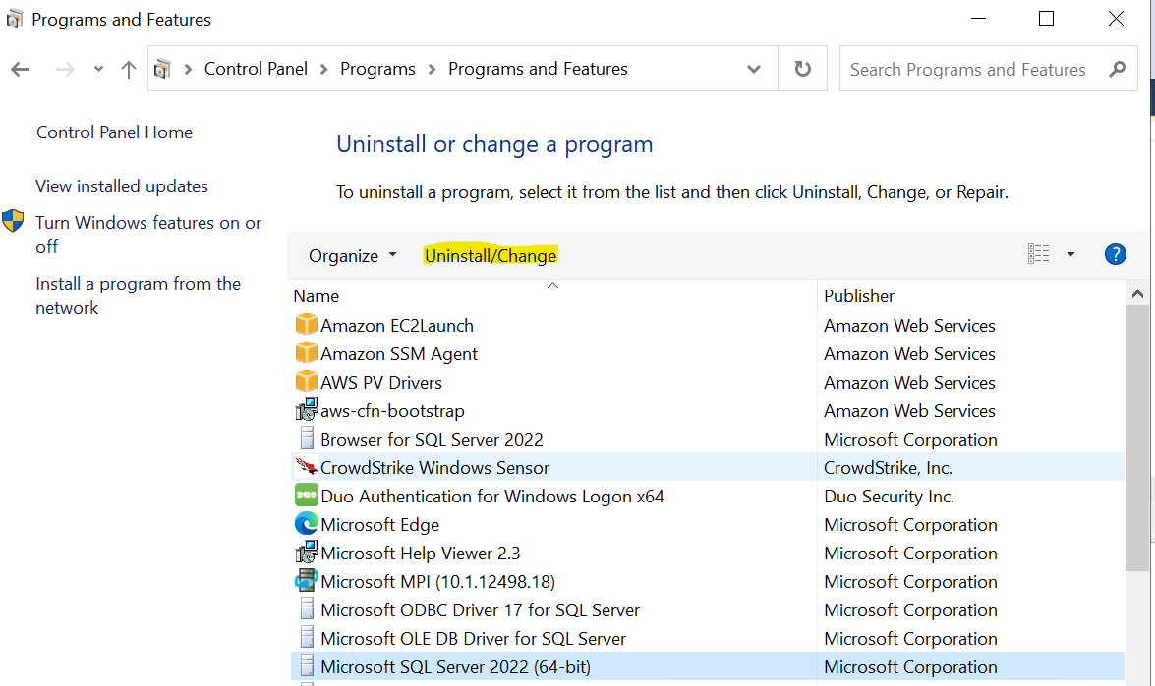
Click continue/yes if needed when prompted about other users being logged in and UAC. When the SQL Server #### window comes up, select Remove.
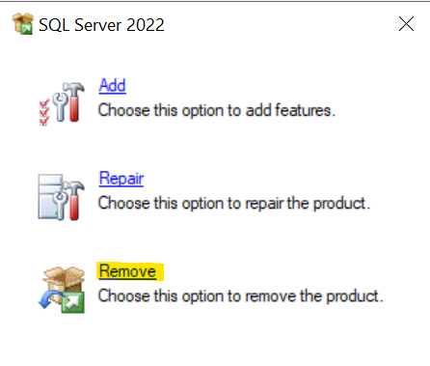
On the Remove SQL Server #### window, Select Instance tab, use the dropdown to select the instance to remove and then click "Next".
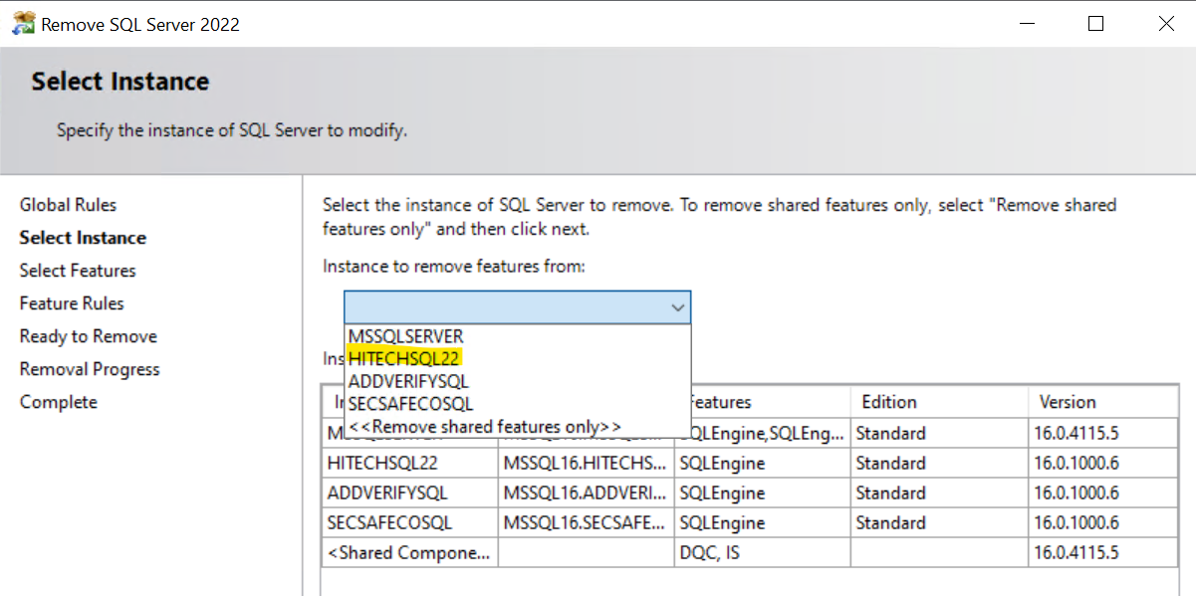
Select all installed SQL features (default is just Database Engine Services) then click "Next".
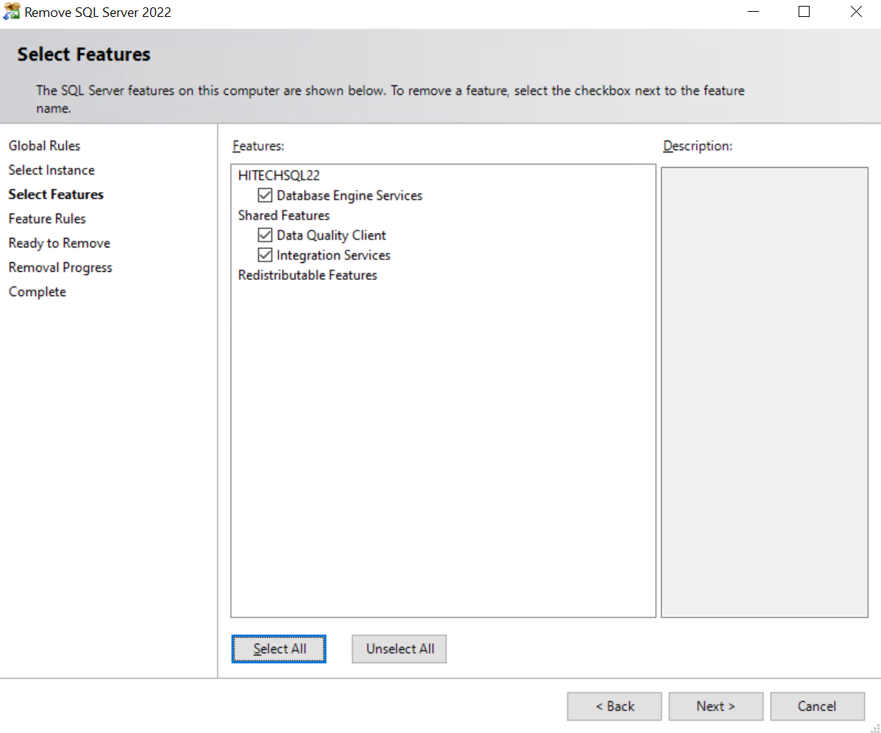Review the information on the Ready to Remove tab and then click Remove. This will uninstall the selected Named Instance and its selected features. Do not reboot if prompted. This should be fine to leave until monthly maintenance reboots to fully remove.
On the communal SQL server that hosted the customer's SQL instance, launch MSP360 (Start > Bold Perennial > Online Backup). Find the customer's Backup Plan and expand it. Click Delete at the bottom of their Backup Plan info. Click the "Yes" button on the following prompt to confirm deleting the Backup Plan. The retention plan should clear out their data automatically as it ages past a week.
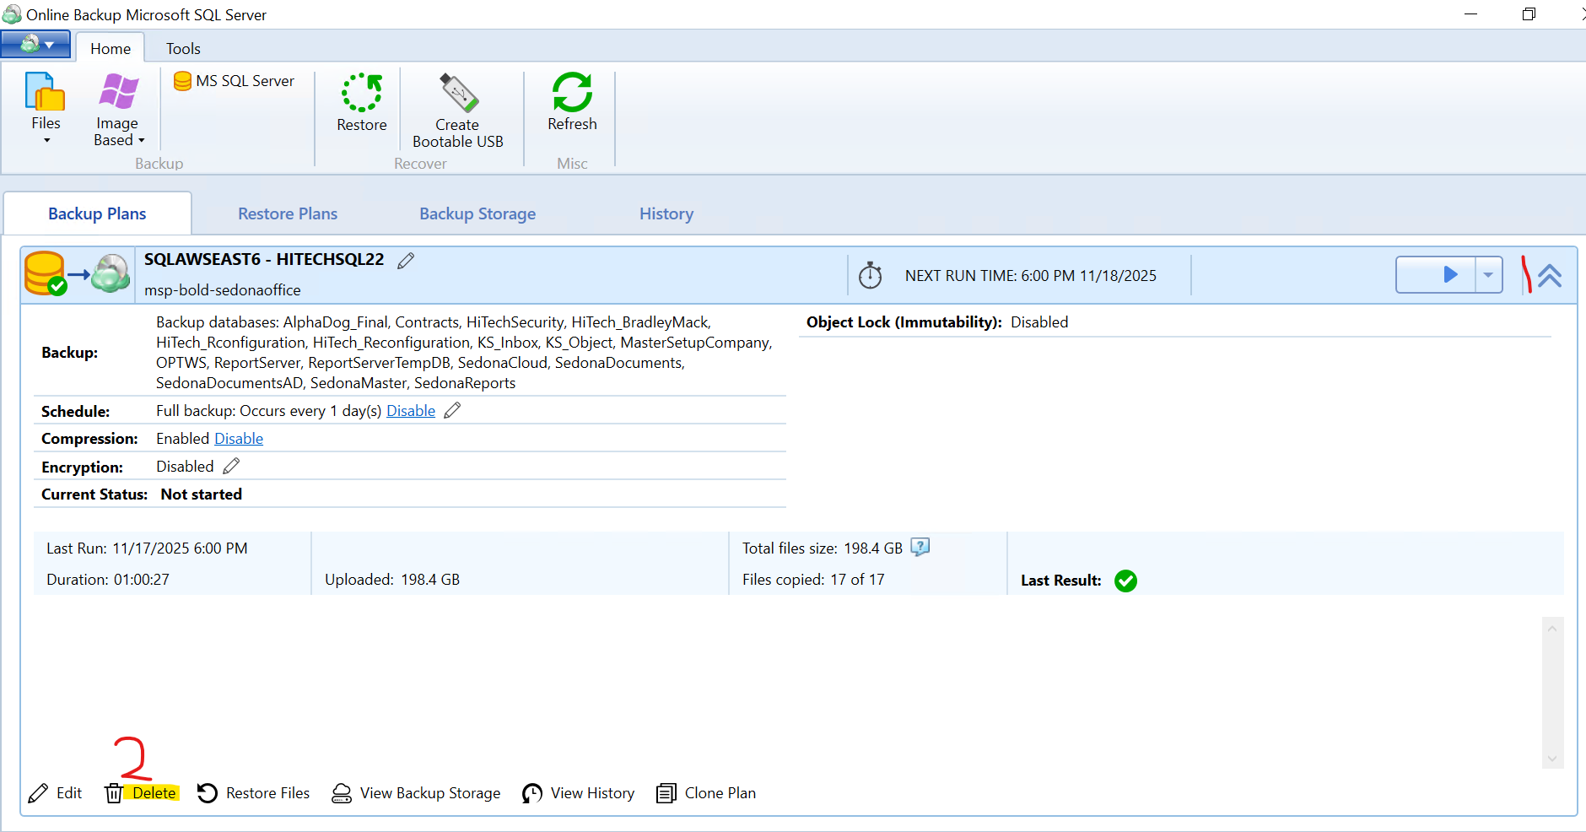

AlarmBiller/Managely
Login to the appropriate AlarmBiller or Managely SQL server (may need to use SQL user creds; e.g. ABRDSE for Alarmbiller). Locate customer's database by the provided Dealer #. Right-click and delete the cancelled customer's database and only the cancelled customer's database (be sure of your selection before deleting the database).
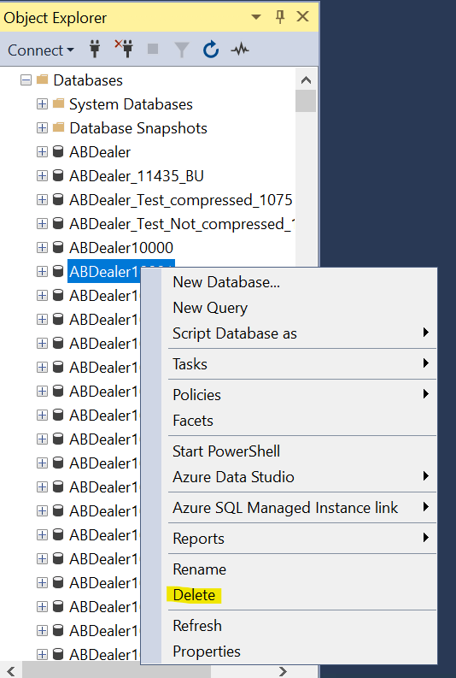
Login to the appropriate Alarmbiller or Managely web server that hosts documents. Find the Dealer's documents folder in the directory by Dealer # (depending on the customer and product, they may have documents folders in multiple subfolders on the Documents drive). Right-click and delete that dealer's folder (again be sure you have just the cancelled dealer's folder selected).
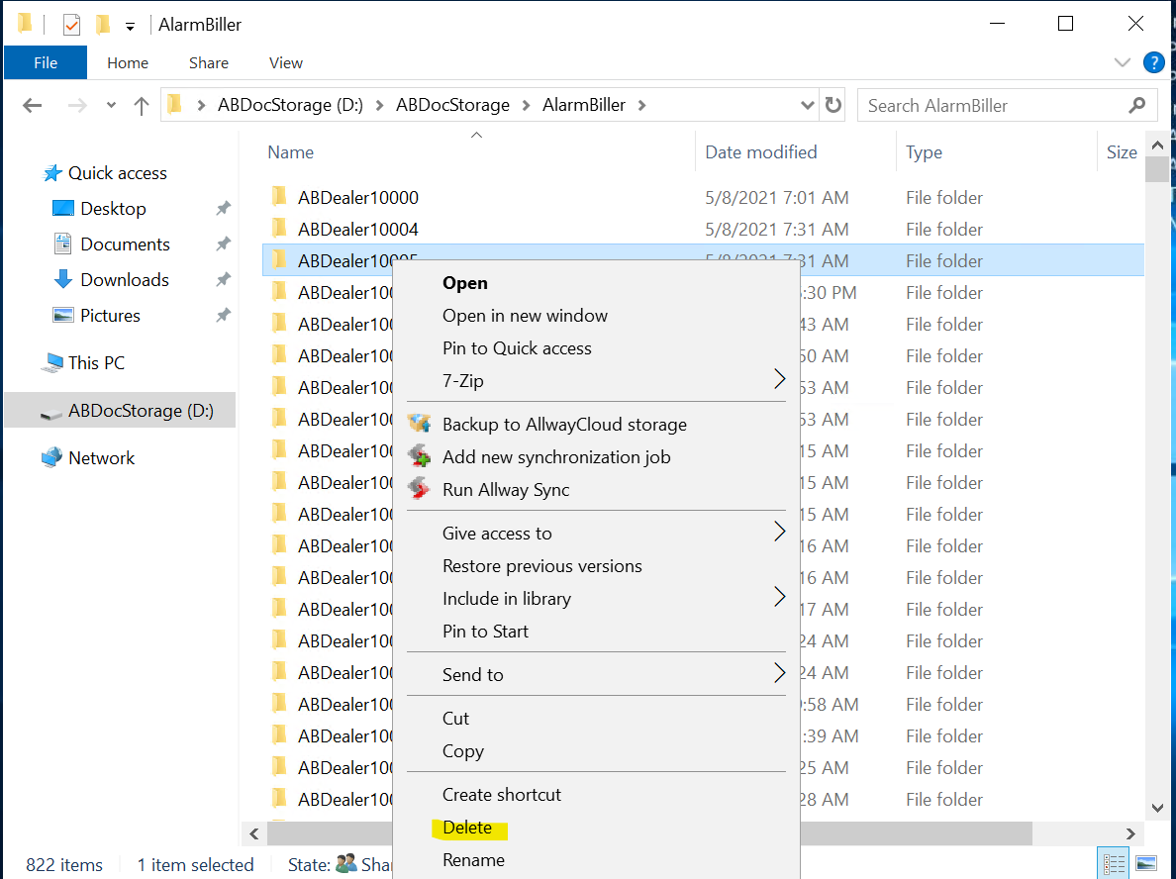

SedonaSync
There shouldn't be a forced reboot during the process, but since the Sync v10 installer has been unreliable about forcing reboots, we want to do this during an agreed upon window in the off chance a reboot is forced without prompting. During the agreed upon window for maintenance, login to the customer's TSPlus server. Launch Control Panel and navigate to Programs and Features. Locate SedonaSync/Knowledgesync, select it, and uninstall. Follow the uninstaller prompts. If they were using v10 of SedonaSync, verify the SedonaSyncPortal/KSPortal site is removed from IIS.
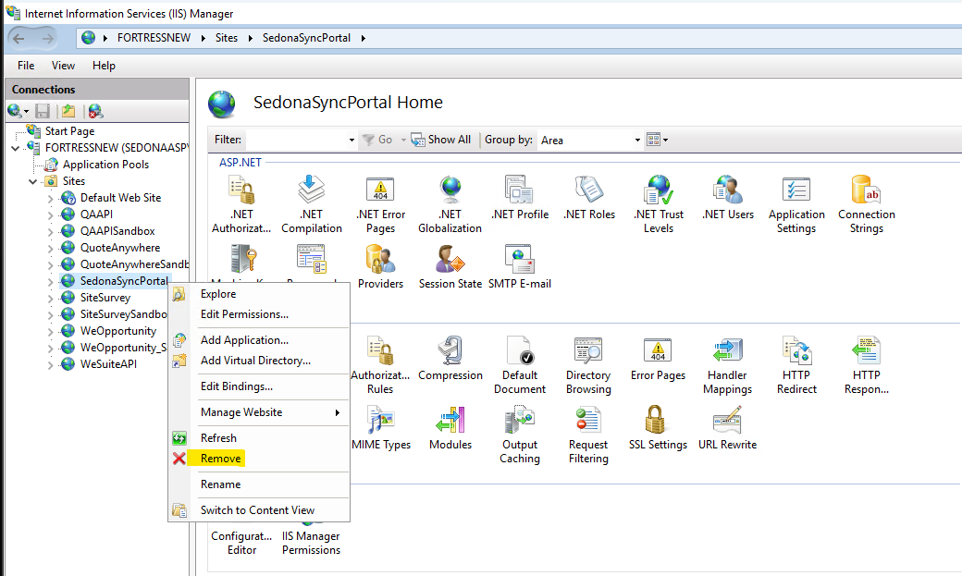
Login to the Customer's SQL instance in SSMS on the communal SQL server hosting them (find under their Server Information in SalesForce: Hosted SedonaOffice > SQL Version; see SQL and MSP360 heading above). Verify the KS_Inbox, KS_Object, and, if using Sync v10, KS_EPak databases are removed. If not, right-click each and delete.
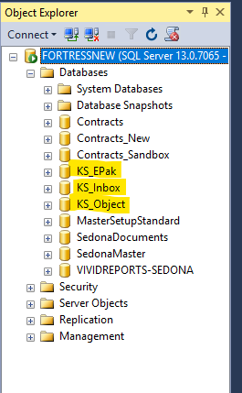
If they were using OPT with SedonaSync, delete the SedonaReports database and OPTWS database if either exists.
SedonaWeb Legacy
Login to the hosted SedonaWeb Legacy IIS server. Open IIS Manager (Start > Windows Adminitrative Tools > Internet Information Services (IIS) Manager if not open or in shortcuts/quickbar) and locate the customer's SedonaWeb. With their SedonaWeb selected, click Explore.
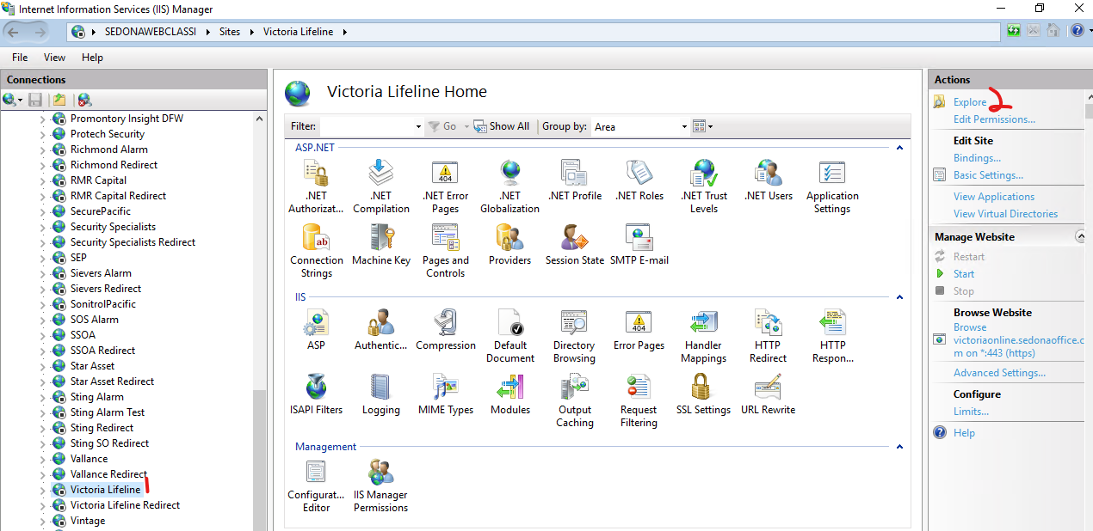
Move 1 folder up and delete the folder you were just in. If the customer has subfolders for previous versions of SedonaWeb, delete those too.
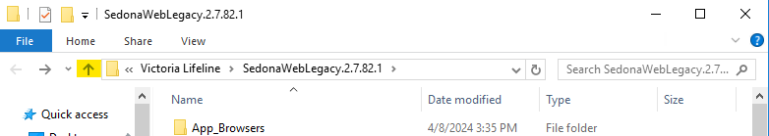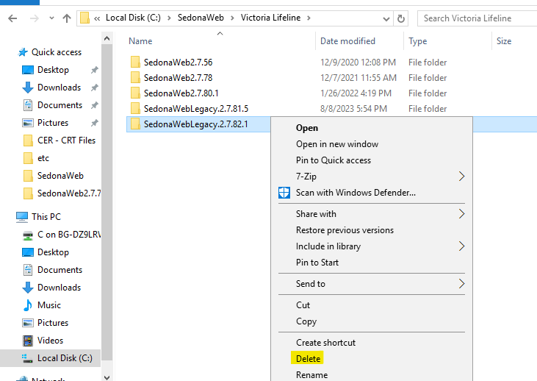
In IIS, note the site URL, then right-click on the site and Remove it.
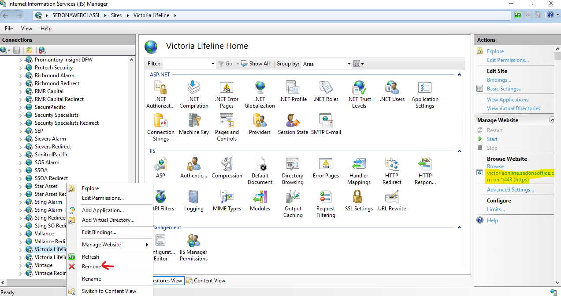Do the same for the redirect site if applicable. Login to Cloudflare and under the BoldGroup account navigate to either SedonaOffice.com > DNS or SedonaASP.com > DNS based on the URL noted above. Find and select the DNS records for the customer using the URL noted above. Verify these DNS records are pointing to the SedonaWeb Legacy server IP: 44.233.75.66. Click the "Delete x Records" button above the list. Type DELETE and click "Delete" to confirm.
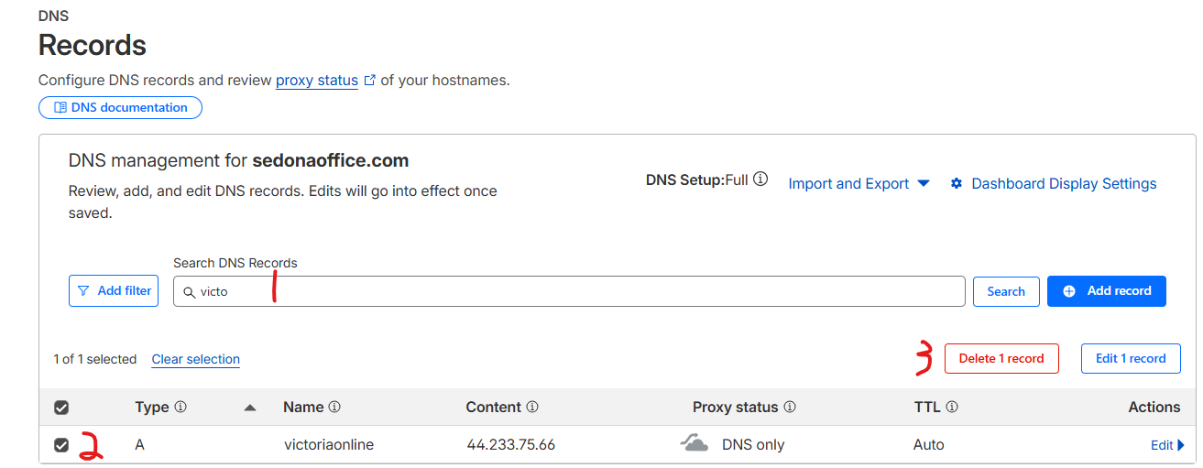

SedonaCloud (API/SedonaWeb 2.0)
Login to the hosted SedonaAPI IIS server. Open IIS Manager and locate the customer's SedonaAPI. With their SedonaAPI selected, click Explore.
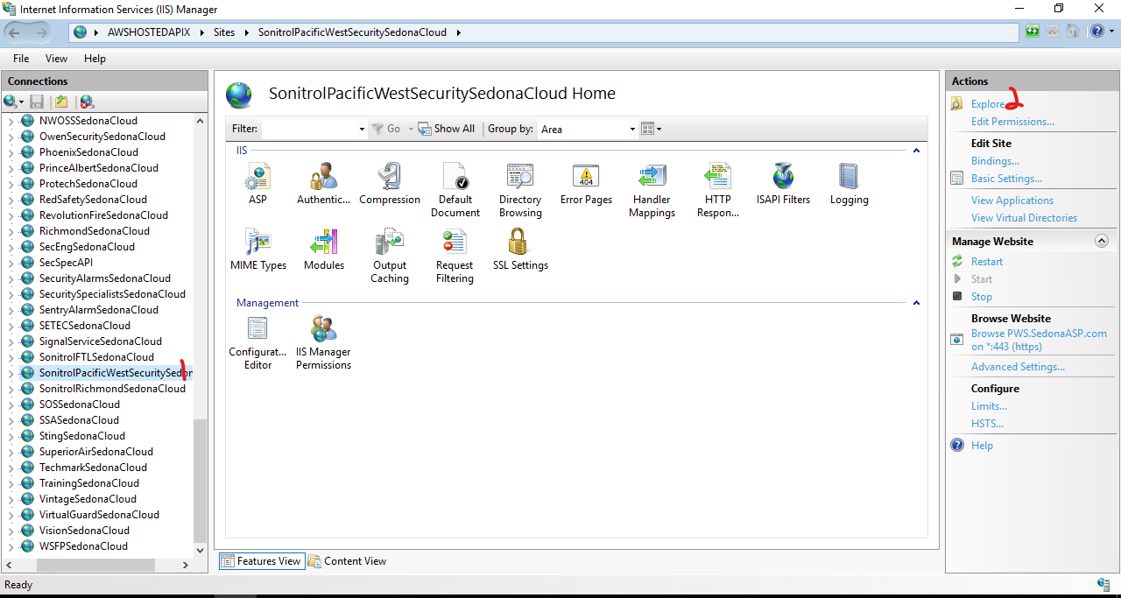
Move 1 folder up and delete the folder you were just in.
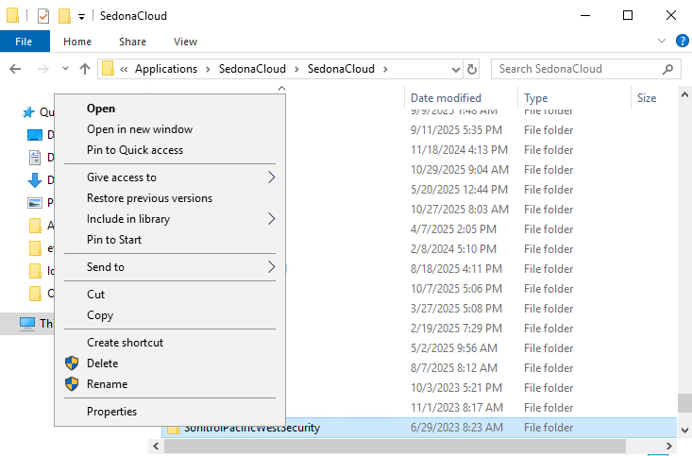
In IIS, note the site URL, then right-click on the site and Remove it.
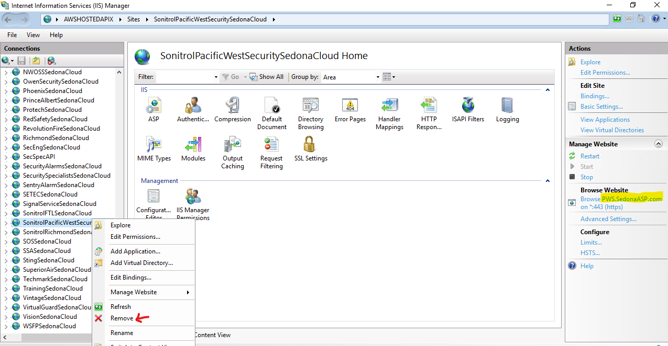
Login to Cloudflare and under the BoldGroup account navigate to SedonaASP.com > DNS based on the URL noted above. Find and select the DNS records for the customer using the URL noted above. Verify these DNS records are pointing to the SedonaAPI server IP: 54.214.143.35. Click the "Delete x Records" button above the list. Type DELETE and click "Delete" to confirm.
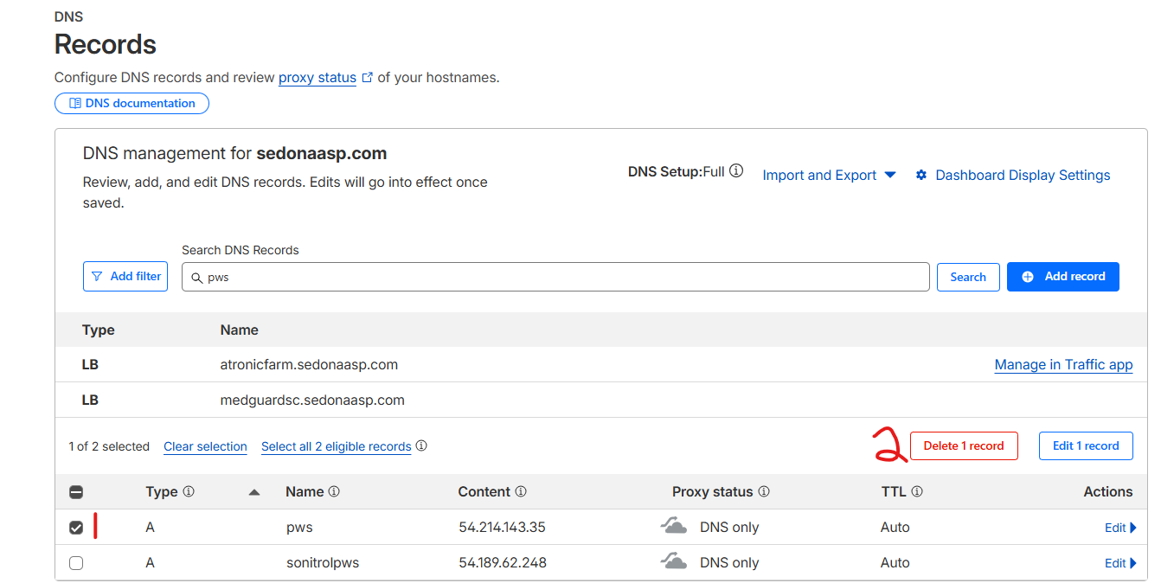
Login to Octopus (http://alarmbillerdeployment.perennialsoftware.com:8080/octopus/). On the Projects tab scroll down to either SedonaAPI (legacy API) or SedonaCloud (API/Web 2.0) and locate the customer's project (you may need to click on "load all" at the end of the list if the project is not initially visible). Click on their project to enter it.
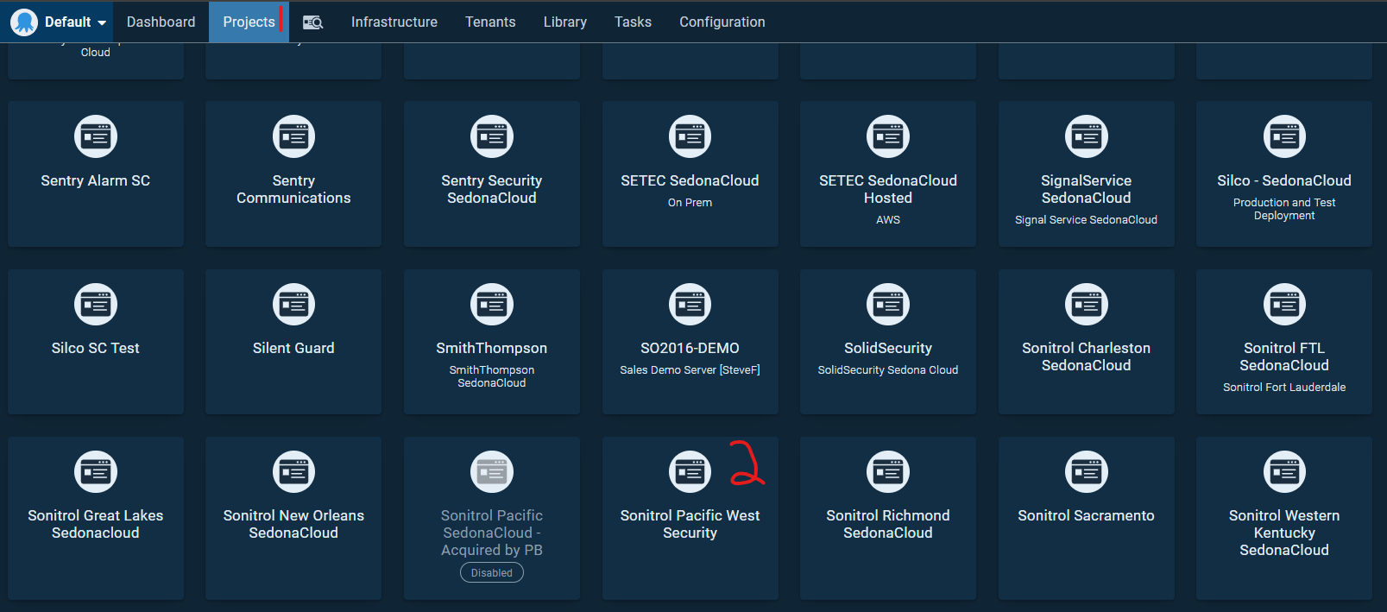
Go to Settings in the left pane > Click the "..." at the top-right of the middle pane > Click Delete.
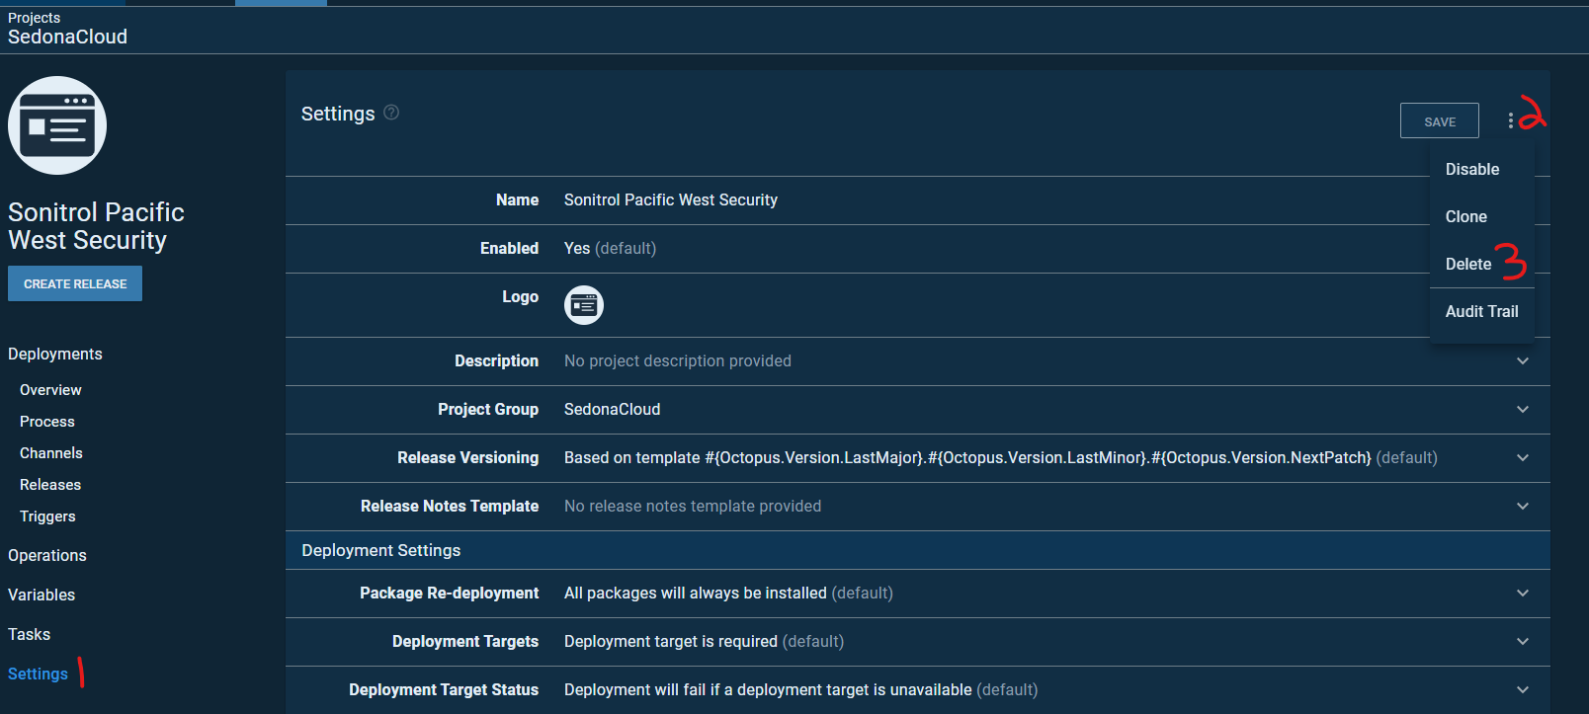
Login to the SQL server hosting the customer's SQL instance (find in SalesForce under the customer's Server Information > SedonaOffice Hosted > SQL Version). Launch SSMS and login to the customer's named instance. Find the SedonaCloud database. Right-click > Delete.

WeSuite
WeSuite should handle the application and IIS cleanup. Infrastructure should be notified on cancellation to verify database clean-up and remove DNS. For DNS clean-up, login to AWS EC2 and navigate to Target Groups. Verify if there is a WS, OPTWS, or HTTPS target group for the customer. If so, select the Target Group and go to the associated Load Balancer under the Target Group details.
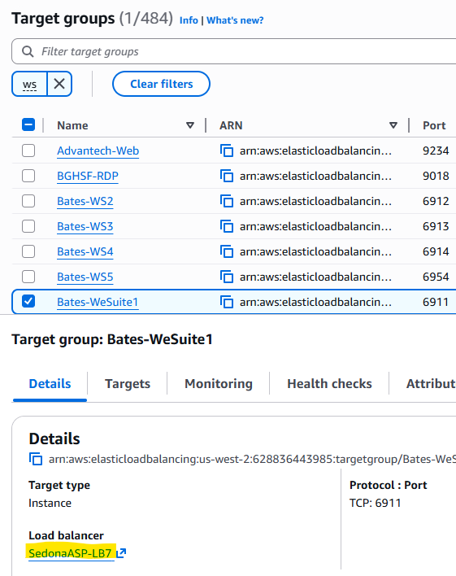
On the Load Balancer page, under Network Mapping, find the public IP following "Use an EIP:".
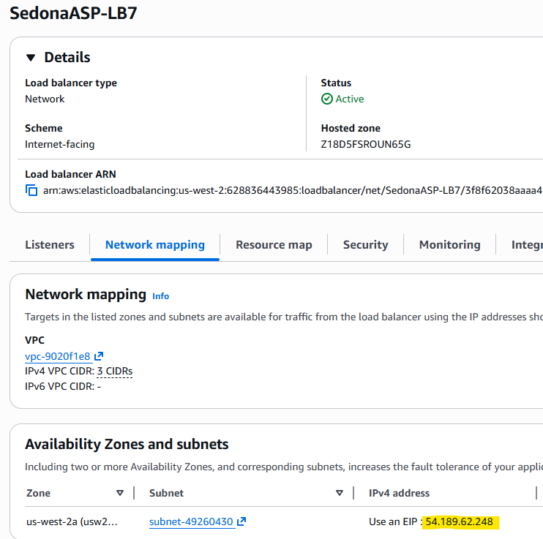Login to Cloudflare, under the Boldgroup account navigate to SedonaASP.com > DNS. Find any entries for wesuite, wesuitego, weopp, sitesurvey, quoteanywhere, qa, qaapi, approval and the customer name using that public IP (newer WS installs will have a comment referencing customer name WS per case #). Select them then click the "Delete X Records" button above the list. Type DELETE and click "Delete" to confirm.
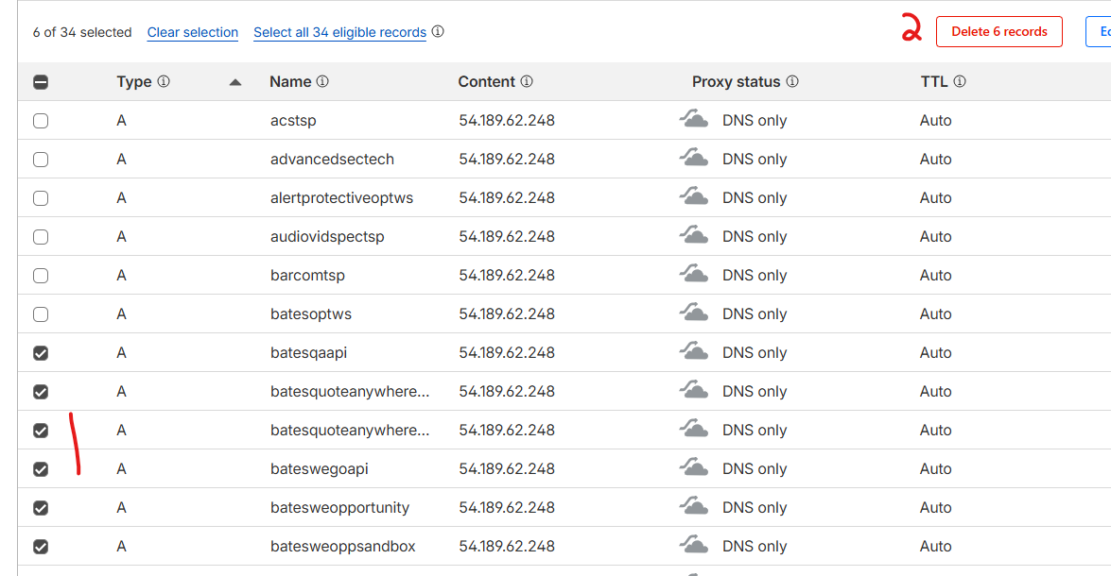
For verifying database clean-up, login to the SQL server hosting the customer's named instance (recorded in Salesforce in customer's Server Information > SedonaOffice Hosted > SQL Version). Open SSMS and login to the customer's named instance. Locate the Contracts and, if applicable, Contracts_Sandbox databases. Right-click and delete those databases.
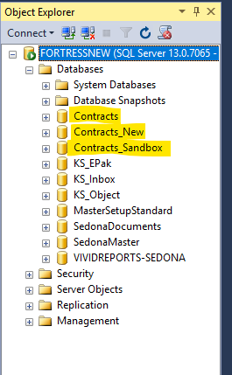

Enterprise Hosted SedonaWeb
Open IIS Manager (Start > Windows Adminitrative Tools > Internet Information Services (IIS) Manager if not open or in shortcuts/quickbar) and locate the customer's SedonaWeb. With their SedonaWeb selected, click Explore.
Move 1 folder up and delete the folder you were just in. If the customer has subfolders for previous versions of SedonaWeb, delete those too.
In IIS, note the site URL, then right-click on the site and Remove it.
Do the same for the redirect site if applicable. Login to Cloudflare and under the BoldGroup account navigate to either SedonaOffice.com > DNS or SedonaASP.com > DNS based on the URL noted above. Find and select the DNS records for the customer using the URL noted above. Click the "Delete x Records" button above the list. Type DELETE and click "Delete" to confirm.

On-prem SedonaBackup
Login to MSP360 (https://mspbackups.com/Admin/Login.aspx). Locate the customer's computer(s) via Computers > use the dropdown to select the customer's "SOENT-CustomerName" account. Click the vertical "..." button on the far right > Delete Computer.
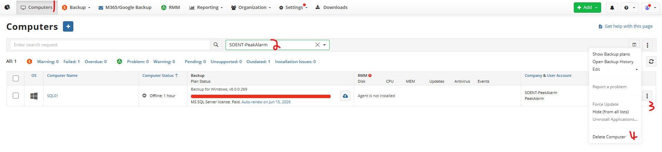Do not delete data. Retention policy will clear it out of S3 over time.
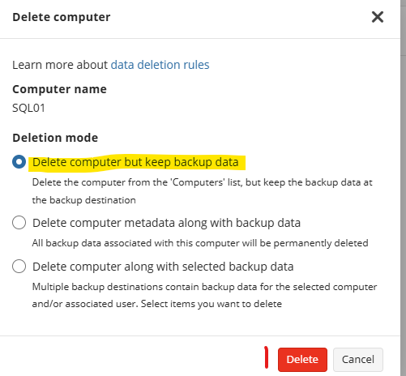
Confirm deletion from MSP360.

