
BoldU Admin
Check BoldU email and BoldU Case Queue daily (put a recurring event on your calendar if needed).
Go into SalesForce and confirm that the requested Learning Manager is set up as a Contact. (If the request is coming from a case, then they are probably in SF already). If they are not a Contact, then they will need to be set up as a New Contact. From the Contact page, click on New, then enter their first and last name and their work email address, then hit Save.
Also, while in SF, check to see if they have a Learning Manager already listed on their Account Page (to see if it needs to be updated).
Once that information has been verified, go into BoldU>Groups>Search to see if that company has already been set up in our system. If the company has already been set up, then you can look at the Managers/Users to see if the person you have been requested to set up is already in there.
If the company is not in there, go to Actions>Add Group.
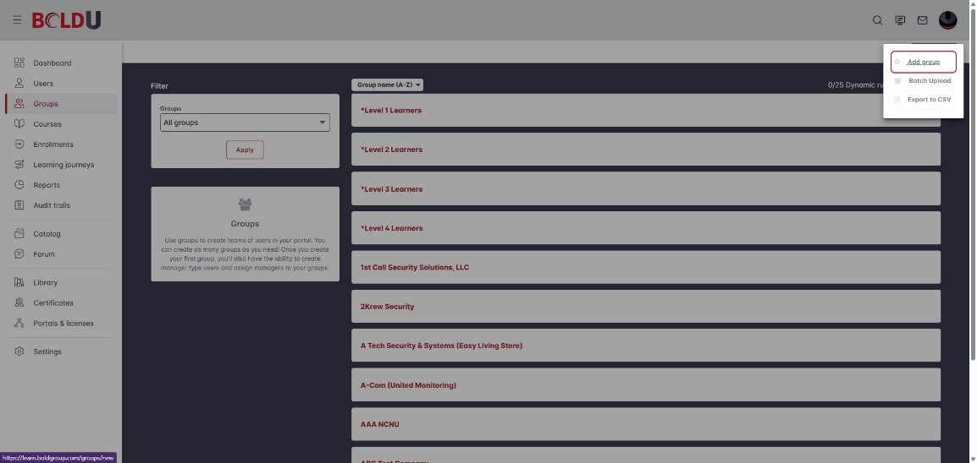
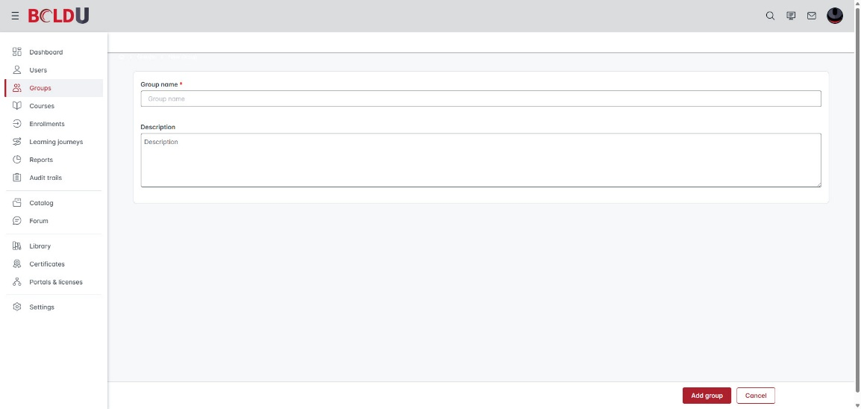
Enter Company Name (as it shows in SF) in name field, Learning Manager - <LM Name>, and Product(s).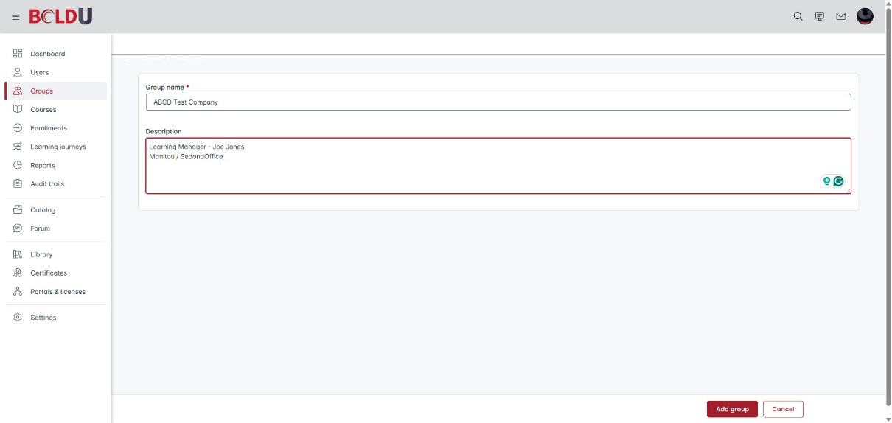
Click Save (the Group created successfully alert should appear).
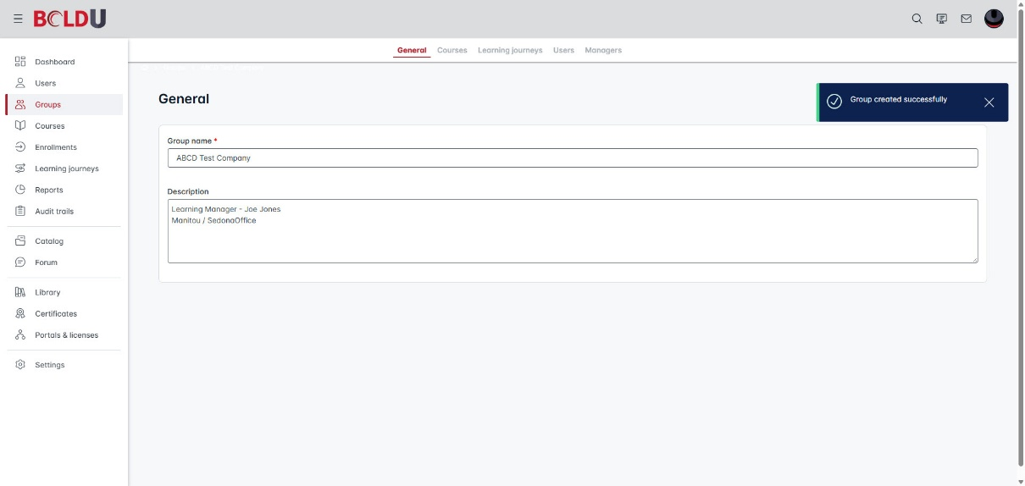
The next step is to add the Learning Manager(s). Go to Users>Action>Create.
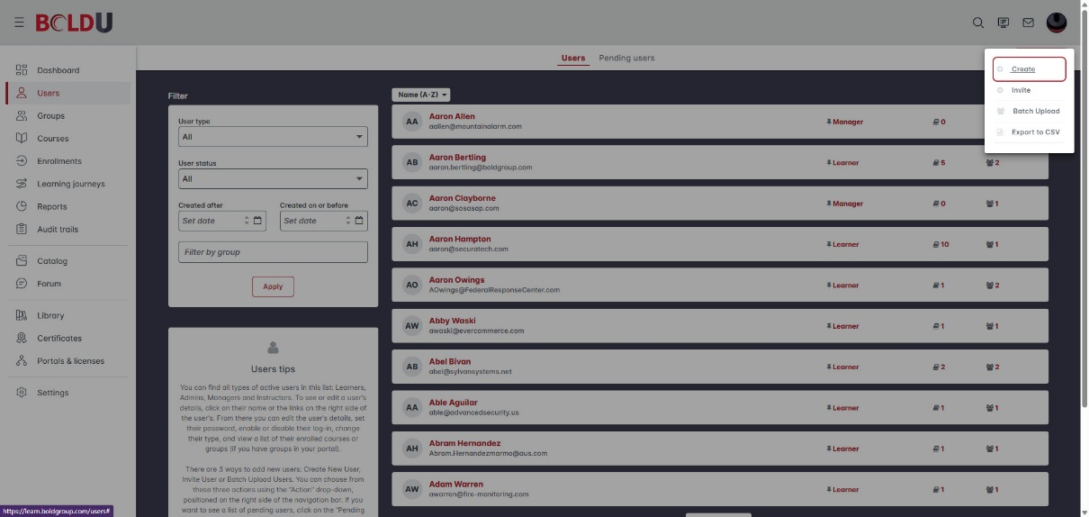
Enter the First Name, Last Name, Email of the Learning Manager, and change the Type of user to Manager. Disable the Send invite to user? option, and then choose the following options under Manager (Can update users; Can unenroll..; Can enroll…; Can manually mark…)
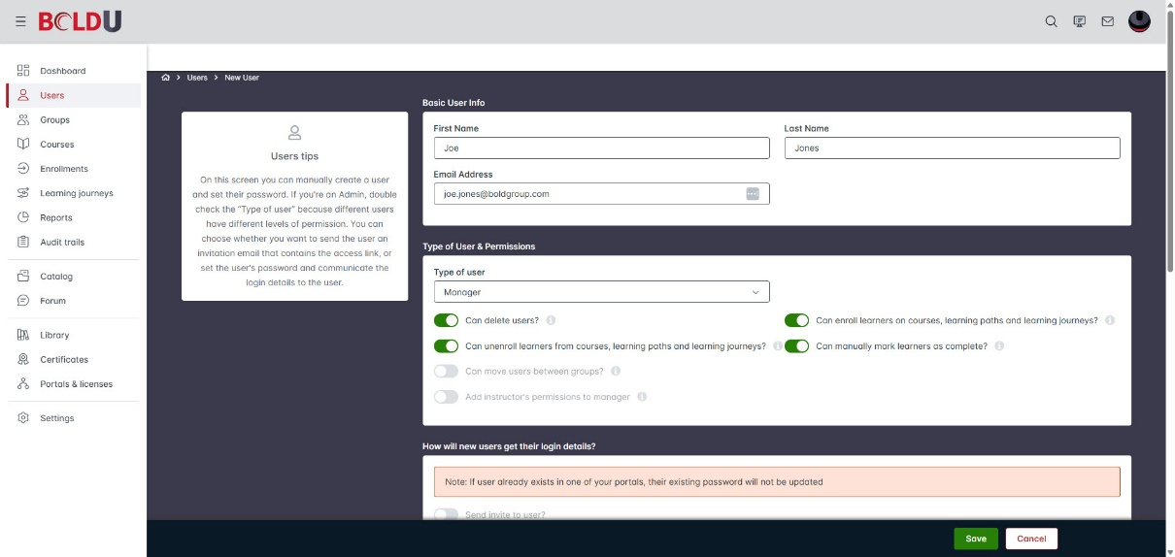
Enter a temporary password of L3@rn2025 into the Enter Password and Confirm Password fields and enable the option for User must change password on login.
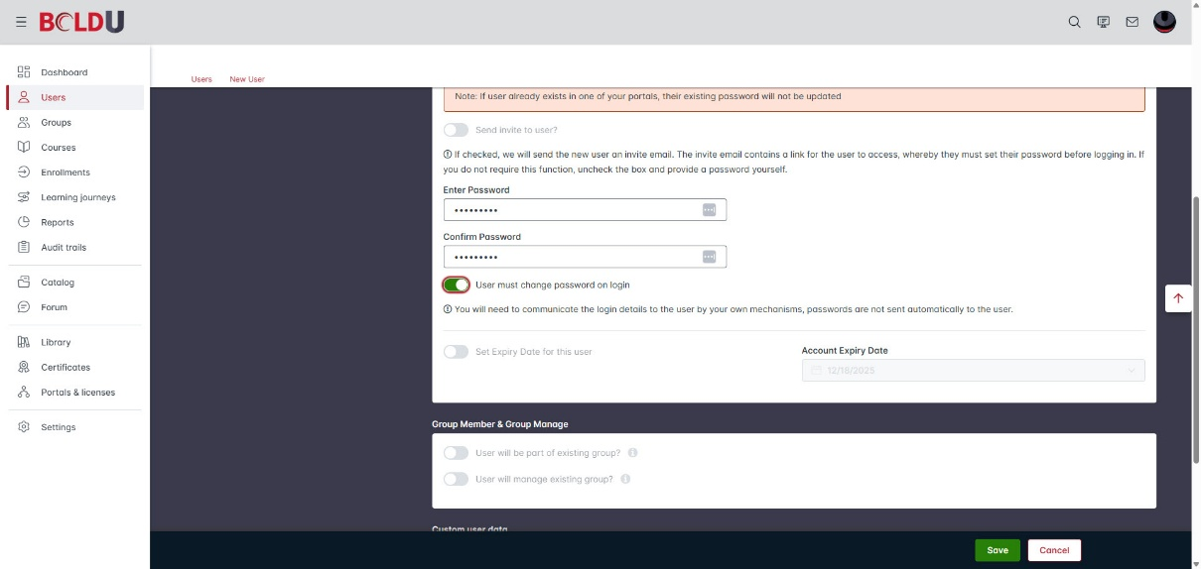
Enter Group Member & Group Manage information (the first few letters of the group name can be entered into the field to make the group name easier to locate). The Custom User Field information can be entered (Company Name, Alarm Monitoring/Business Management product).
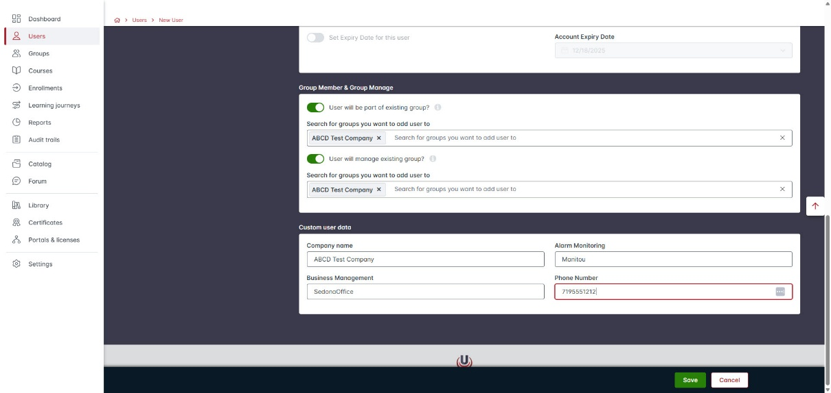
Then click Save (a Success alert should appear).
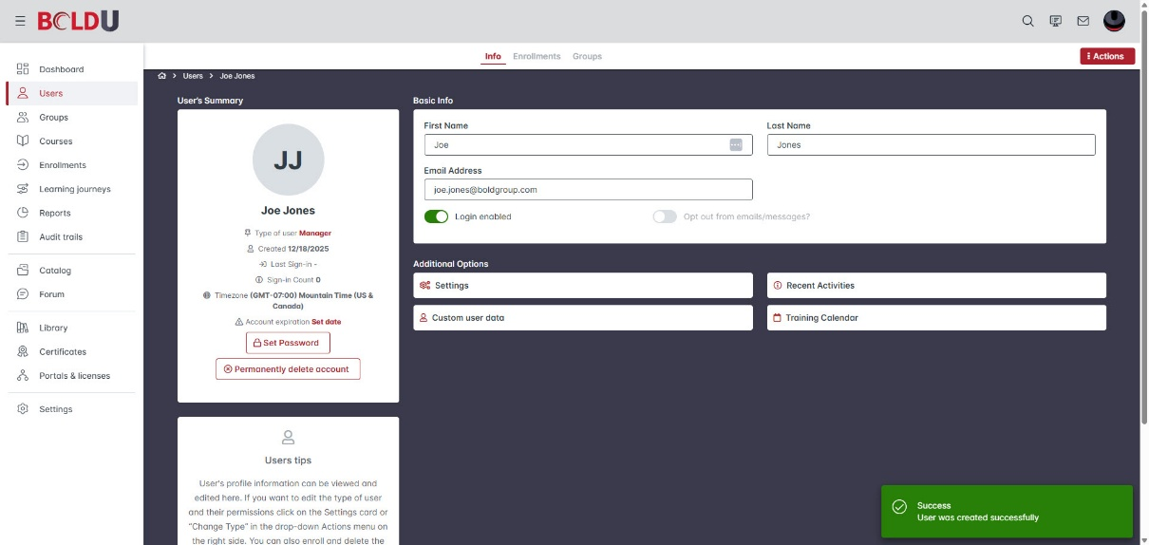
Once on the newly created user, click on Settings. This is where the Group Permissions to select the Company that the Learning Manager will be able to create users/approve enrollments.
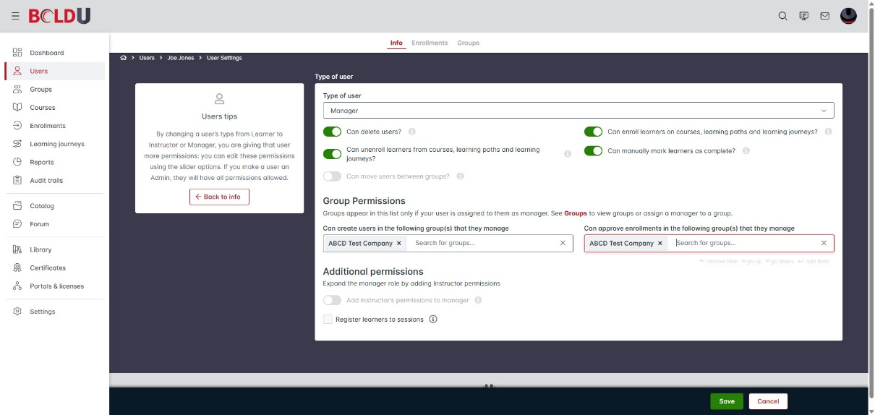
Click Save, and the Learning Manager set up will be complete.
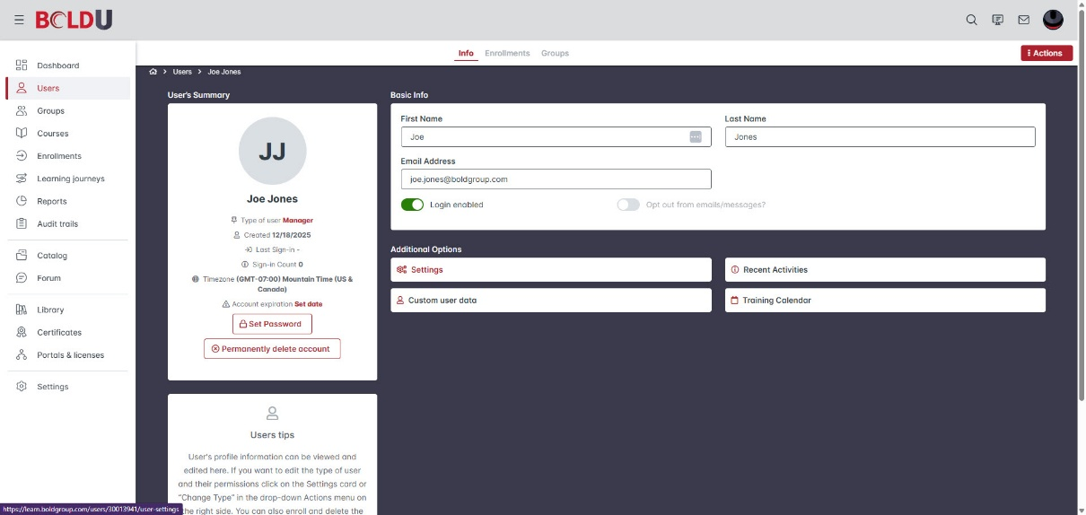
Now the customer will need to be sent the Learning Manager email that gives them instructions on logging into BoldU and has the Learning Manager guide attached. (Make sure to change the “sending” email address)
Also, if the request came through the BoldU email, then respond that the request has been completed and an additional email has been sent out with login information.
If the request came through a SF case, then the case will need to be closed out.
  - Assign the case to yourself.
  - Go to Edit to change the required fields –
    - Status – Closed
    - Product – Manitou
    - Sub Product – Other
    - Functional Area – Other
    - Request Category – Login/Access Request
    - Request Type – BoldU login/access
    - Billable/Non-Billable – Non-Billable
  - Resolution Details
    - Resolution – Solved (Permanently)
    - Resolution Details – Customer provided with login credentials to BoldU
    - Cause code – Other
  - Save

