Sedona Office New Server Installation Guide
Contents
Sedona Office New Server Installation Guide 1
Sedona System Requirements 2
Sedona PreRequisites 3
Install Necessary Roles and Features 3
Add Roles and Features 3
SQL Installation 5
Planning/Prepping the Install 5
Installing the SQL Server Instance 5
Install SQL Server Management Tools 6
Final Configuration 7
Installing Sedona 7
Installing Sedona Server 7
Installing Sedona Client 11
Updating Sedona Office 15
Updating Sedona Server/Client to 5.7.0.99 15
Updating Sedona Server/Client from 5.7.0.99 to 6.1.0.33 20
Testing SedonaOffice 24

Sedona System Requirements
Basic Workstation:
- Intel or AMD CPU (Multi-Core) 2.0 GHz+ (example: Intel® Core™ i5-4430 Processor)
- Windows 8, Windows 8.1 or Windows 10,
- 4 Gig of Ram
- Hard Drive 60Gb+ (minimum of 250megs free)
- Monitor capable of 1024 by 768 resolution
- 10/100/1000Mbs Network Card (TCP/IP)
Basic Server (Up to 20 Workstations*)
- Intel or AMD Server Class CPU (Multi-Core) 2.0 GHz+ (example: Intel® Xeon® Processor E5-4603)
- Microsoft Windows 2012, 2012 R2 or 2016 Server Standard x64
- SQL 2012, 2014, 2016 or 2019 Standard x64
- 8+ Gigs of Ram
- Raid 1 (or better) Hard Drive for Operating System (+120GB)
- Raid 1 (or better) Hard Drive for Databases (+160GB)
- 10/100/1000Mbs Network Card (TCP/IP)
Advanced Server (21 to 50 Workstations*):
- Intel or AMD Server Class CPU (Multi-Core) 2.4 GHz+ (example: Intel® Xeon® Processor E5-4640)
- Microsoft Windows 2012, 2012 R2 or 2916 Server Standard x64
- SQL 2012, 2014, 2016 or 2019 Standard x64
- 16+ Gigs of Ram
- Raid 1 (or better) Hard Drive for Operating System (+120GB)
- Raid 5 (or better) Hard Drive for Databases (+300GB)
- 10/100/1000Mbs Network Card (TCP/IP)
Enterprise Server (51 to 100+ Workstations **):
- Dual Intel or AMD Server Class CPUs (Multi-Core) 3.0 GHz+ (example: Intel® Xeon® Processor E5-1680 v3)
- Microsoft Windows 2012, 2012 R2 or 2016 Server Standard x64
- SQL 2012, 2014, 2016 or 2019 Standard x64
- 24+ Gigs of Ram
- Raid 1 (or better) Hard Drive for Operating System (+120GB)
- Raid 5 (or better) Hard Drive for Database (+300GB)
- 10/100/1000Mbs Network Card (TCP/IP)

Sedona PreRequisites
Before starting the Sedona Server installation, please verify all of the following are in place. All exceptions to this will need to be recorded in the CRM for the project.
All Sedona Files can be downloaded from http://files.sedonaoffice.com/
- All Windows Updates Completed and the server restarted
- Installer files are copied to the machine
  - SOClient5.6.8 Installer
  - SOServer5.7.0.0.Rev2 Installer
  - SedonaOffice_Update_57099_Rev_1 Installer
  - SedonaOffice_Update_61025_Rev_1 Installer
  - SedonaOffice_Update_61027_Rev_2 Installer
  - SedonaOffice_Update_61033_Rev_1 Installer
  - SQL Installation Media
- Verify Hard Drive Space is sized according to the SCD sent to the customer
- Verify with customer that server will NOT be renamed post-installation
- Verify the server(s) have a Static IP address and not DHCP
- Verify that all machines can communicate across the network by Name and IP.
- Verify that Installation User has Full Administration Rights to computer(s).
- Verify that all transferred/downloaded files have NO NTFS permissions errors or blocks.

Install Necessary Roles and Features

Add Roles and Features
- Open Server manager
- Click Manage then select Add Roles and Features. Alternatively, select Add Roles and Features from the Welcome Tile.
- Select Role-Based or Feature-Based Installation
- Select the intended Server that needs features installed, then click Next.
- Select Next on the Roles Page.
- At the Features Page expand .Net Framework 3.5 Features and check the box for .Net Framework 3.5.
- Select Next, confirm the details of the installation then select Install.
NOTE: If you are prompted for an alternate source path at the Confirm Installations page, follow the instructions below.

.NET 3.5 Source File Fix
- Run gpedit.msc
- Expand Computer Configuration → Administrative Templates
- Select System
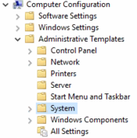
- Right-click the setting Specify settings for optional component installation and component repair and select Edit.
- Set to Enabled.
- Check the box that says Download repair content and optional features directly from Windows Update instead of Windows Server Update Services (WSUS) then select OK.
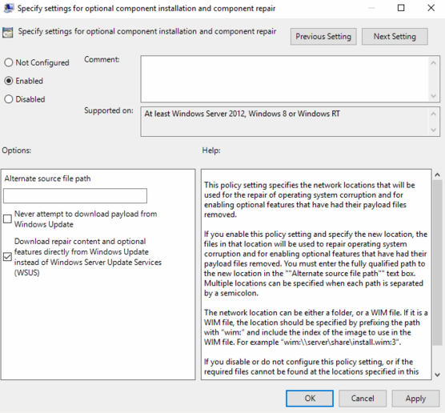
- Close the gpedit application.
- Launch a command prompt as administrator
- Type in and run the following command
DISM /enable-feature /featurename:NetFx3 /online /all
- Return to the Add Roles and Features application and re-install any necessary roles or features.

SQL Installation
SQL installs are typically done by the customer, the following steps are here in the event you need to conduct the install.
If "SQL Express" is being used for App/Witness server purposes, note:
"Backward compatibility" being selected is essential. This feature is available on SQL Express Advanced edition but not the "basic" version that installs by default.

Planning/Prepping the Install
Before starting the install of SQL please outline the following in your own notes. Verify that the customer is aware of these if needed.
- Note the local or domain users that will be used for the SQL Windows Administration accounts.
- Verify the drives the installation will include. It is highly recommended we have:
  - 1 OS drive
  - 1 SQL drive
- Determine where the SQL Installation Media is stored and keep a backup on hand for possible future emergency installs.
  - NOTE: This step is required for UL. All installation media will need to be on hand for any emergency events requiring re-installation.
- Verify Windows Updates have been completed.

Installing the SQL Server Instance
The following steps outline the standard installation steps for the SQL server instance
- Start the SQL Server Installation Center, extracting files as necessary.
- Under the Installation Tab select New SQL Server stand-alone installation or add features to an existing installation.
- Leave Use Microsoft Update to check for updates box unchecked, select Next.
- An error message may appear saying SQL Server setup could not search for updates, select Next to proceed.
- The Product Key page will be where the product key can be entered if not already present. If applicable, enter the product key, then select Next. (Express does not require a key)
- Accept the License Terms, leaving the CEIP unchecked unless specified by the customer, select Next.
- On the feature selection page, select ALL Features minus the following:
  - SQL 2016 PolyBase (if applicable)
  - Microsoft R Open (if applicable)
  - Python
  - Java
- Change the Instance Root, Shared Feature, and Shared feature (x86) directors to match the SQL Data drive desired and/or specified, then select Next.
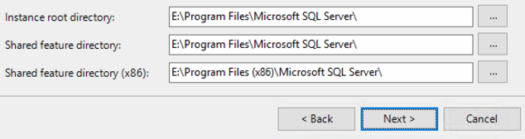
- On the Instance Configuration screen, leave the instance as Default Instance (MSSQLSERVER), select Next.
- From the Server Configuration page, set the SQL Server Agent to Automatic startup.
- Select the Collation tab and verify the Database Engine is set to SQL_Latin1_General_CP1_CI_AS, select Next.
- From the Database Engine Configuration screen, set the Authentication Mode to Mixed Mode
- Enter in a strong password for the SA Account and record it in the CRM under the label SA.
- For the Specify SQL Server administrators, select Add Current User
- Select Add... type in any other account that needs access to SQLthen select Check Names, then select OK to confirm.
  - When adding the user account it may bring a window that says Name Not Found. If it appears to change the location from the Entire Directory to the machine SQL is being installed on.
- Select the Data Directories tab and make sure all directories are set to the intended drive for SQL, select Next.
- Repeat steps 14-16 for Analysis Services, select Next.
- Verify the Install and Configure option is selected for Reporting Services, click Next.
- At the Distributed Replay Controller Screen, select Add Current User... then Add... user MSSQL as completed previously.
- There will be a final verification window, review the options selected and select Install to complete the Instance installation.
- Verify that all features successfully installed at the installation complete screen.
- If necessary, repeat these steps on all additional Database Servers.

Install SQL Server Management Tools
Now that the SQL instance has been installed, it is necessary to install the SQL management tools for the SQL version that was installed. Install the tools using the installer that was already copied to the machine.
If the installation files for the SSMS were not already downloaded to the machine, follow these instructions.
- Open the SQL Server Installation Center if not already open.
- From the Installation Tab, select Install SQL Server Management Tools
- A website will open presenting links to Download SSMS
- Download the latest SSMS General Availability version to the desktop
- Once downloaded run the SSMS setup utility.
- Select Install to begin.
- Once the install is complete, a restart of the server is required.
- If necessary, repeat these steps on all additional Database Servers.

Final Configuration
- Open SQL Server Configuration Manager (Start → Microsoft SQL Server 2016 → SQL Server 2016 Configuration Manager)
  - This must be opened in the same version the instance install was.
- Log in with the SA account using the credentials you made earlier.
- From the SQL Server Configuration Manager, expand SQL Server Network Configuration and select Protocols for MSSQLSERVER
- Right-click on the Named Pipes protocol and select Properties.
- Set Enabled to Yes, then select OK.
- Right-click on the TCP/IP protocol and select properties.
- Verify Enabled is set to Yes.
- Verify Named Pipes and TCP/IP are Enabled.
- Select the IP Addresses Tab, verify all IP Entries are Active, Enabled, and have TCP Port set to 1433.
- Scroll down to IPAII, verify TCP Dynamic Ports is empty, and that the TCP Port is set to 1433.
- Select OK when complete.
- Select SQL Server Services in the navigation pane, Restart all active SQL Services then close the application.
- Open SQL Server Management Studio (Start → Microsoft SQL Server Tools → Microsoft SQL Server Management Studio)
- Log in with the SA account using the credentials you made earlier.
- Right-click the root server node and select Properties.
- Select the Memory tab,
- (Optional) Specify the Maximum server memory (in MB) to be 60% of the total installed memory of the server itself.
- Select the Connections tab and verify the Allow remote connections to this server checkbox is checked.
- Select OK to apply all changes.
- Close the application.

Installing Sedona

Installing Sedona Server
- Create a new folder on the C: drive named "SedonaOfficeImageV40000", or whatever the customer wants, and share it with everyone. This will be used to update the clients over the network.
- Navigate to the Sedona Install Files Directory
- Right-click the "SOServer5.7.0.0.Rev2 installer" and click Run As Admin.
- Click Yes on the UAC prompt
- The installer is now running in the background and will pop up with an install screen after a few minutes
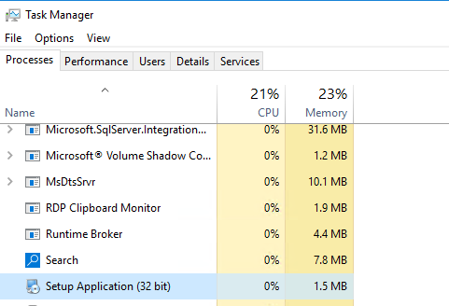
- When the installer UI opens you should see the following prompt about the C/C++ 2012 Update, click OK.
- You will now see a prompt about the C++ 2008 runtime, click OK. Click Next on the C++ 2008 installer, accept the terms and click install, click finish.
- You should now see the prompt about the C++ 2010 runtime files, click OK. Accept the terms and click install and then finish.
- The SedonaOfficeServer Setup should now be open
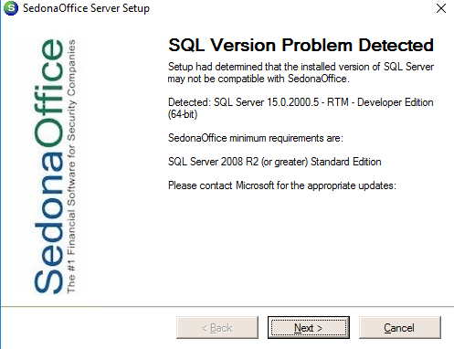
- Click Next and you should see the Welcome Screen
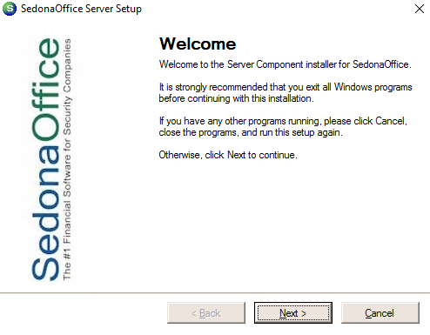
- Click Next to See the Template Database Selection screen
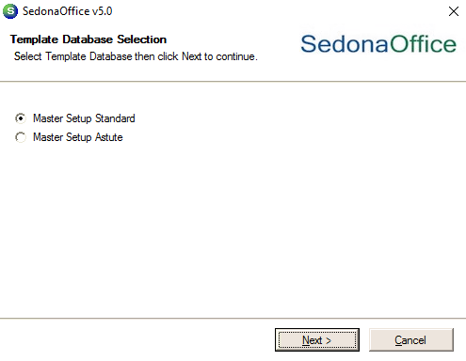
- Click Master Setup Standard and then click Next to see the SedonaOffice Server Defaults screen.
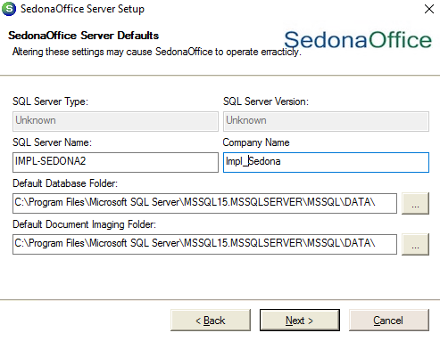
- Change the company name to the customer's chosen name and click Next.
- Once the install is complete you will be greeted by a License screen
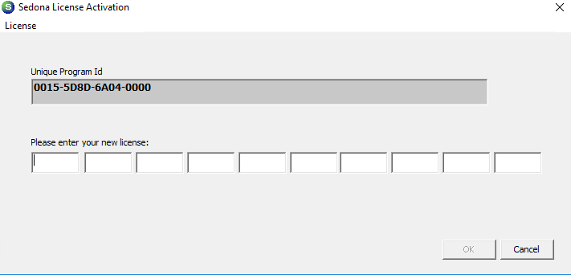
- Contact Sedona for a license key, they will require the Unique Program Id to generate your license key. Once the Key is Generated you need to type it into the new license field and click OK. You should see the following message:
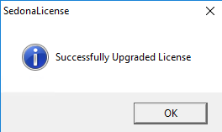
- Click OK to finish the server install.

Installing Sedona Client
- Navigate to the Sedona Install Files Directory
- Right-click the "SOClient5.6.8" and click Run As Admin.
- Click Yes on the UAC prompt
- The installer is now running in the background and will pop up with an install screen after a few minutes
If you get the following error click OK and exit the "Setup Application" from the task manager and relaunch the "SOClient5.6.8" installer.
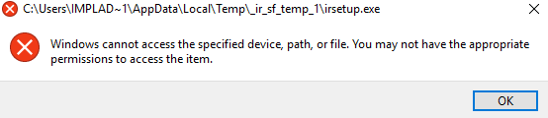
- You should see the Welcome screen when the installation window pops up.
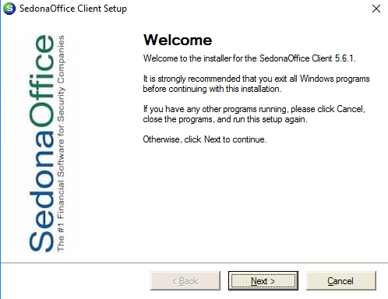
- Click Next
- Agree to the terms and click next
- Type the Customer Name and Company and click next
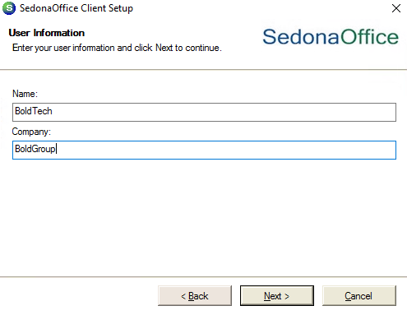
- You should now see the Installation Folder screen, change the installation path if needed and click Next.
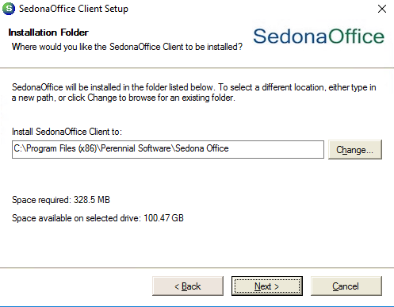
- You should now see the Shortcut Folder screen, click Next.
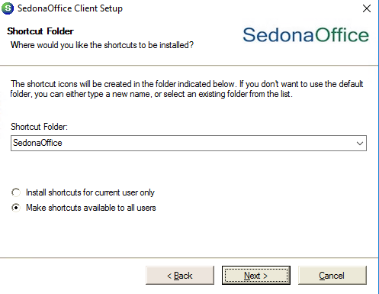
- You should now see the Ready To Install screen, click Next
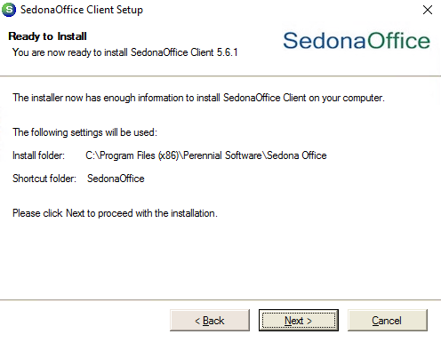
- When the install has finished click Finish
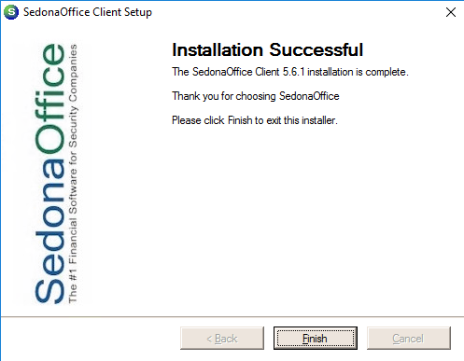

Updating Sedona Office
All new Sedona installs will be on 6.1.0.33. the following steps will detail the upgrade process.

Updating Sedona Server/Client to 5.7.0.99
- Navigate to the Sedona Install Files Directory
- Right-click the "SedonaOffice_Update_57099_Rev_1" and click Run As Admin.
- Click Yes on the UAC prompt
- The installer is now running in the background and will pop up with an install screen after a few minutes
- Agree to the License Agreement Terms and select Next
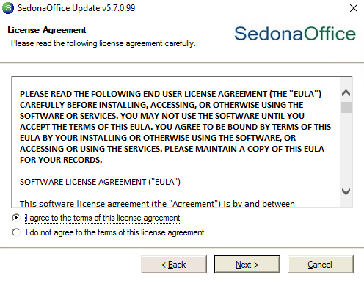
- Click Update Sedona Database and you should get an Account Verification Failed Prompt, you would now contact Sedona to obtain a Day Code.
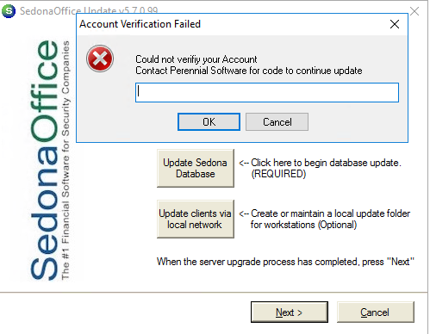
- Enter the Day Code Sedona provided to you and click OK
- You should now see a Sedona Office Server prompt informing you all users must be logged out. Click OK and then click OK to the message stating all users have exited.
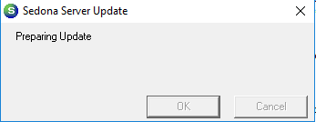
- After the Database update is complete click OK on the prompt
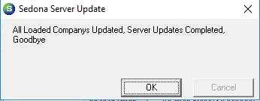
- Now click Update clients via local network.
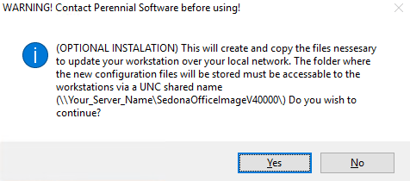
- Click Yes on the prompt and type in the UNC share path you made earlier and click OK
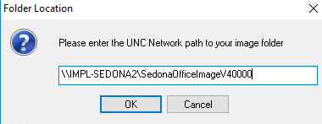
- This will copy the update files into the shared folder for future use
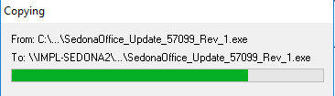
- Click Yes on the Beta Program to get the updates as they are Beta released.
- Click Next to start the client update
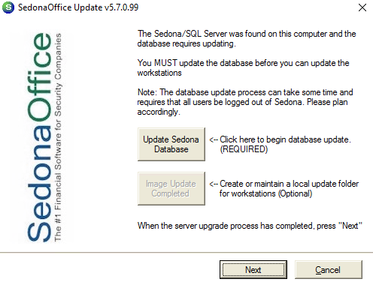
- Click start to begin the update
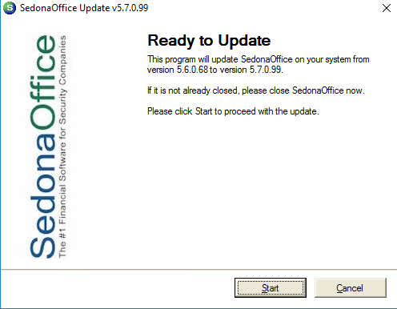
- Click Finish when the update is complete.
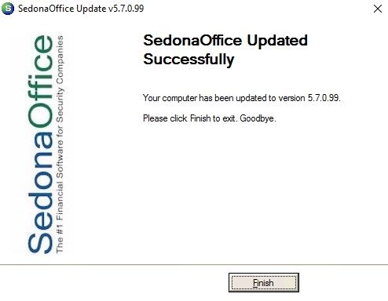

Updating Sedona Server/Client from 5.7.0.99 to 6.1.0.33
- Navigate to the Sedona Install Files Directory
- Right-click the "SedonaOffice_Update_61033_Rev_1" and click Run As Admin.
- Click Yes on the UAC prompt
- The installer is now running in the background and will pop up with an install screen after a few minutes
- Agree to the License Agreement Terms and select Next
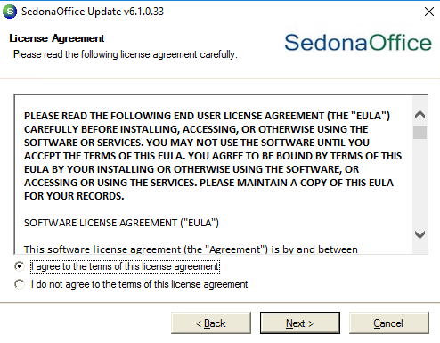
- Click Update Sedona Database and you should get an Account Verification Failed Prompt, you would now contact Sedona to obtain a Day Code.
- Enter the Day Code Sedona provided to you and click OK
- You should now see a Sedona Office Server prompt informing you all users must be logged out. Click OK and then click OK to the message stating all users have exited.
- After the Database update is complete click OK on the prompt
- Now click Update clients via local network.
- Click Yes on the prompt and type in the UNC share path you made earlier and click OK
- This will copy the update files into the shared folder for future use
- Click Yes on the Beta Program to get the updates as they are Beta released.
- Click Next to start the client update
- Click start to begin the update
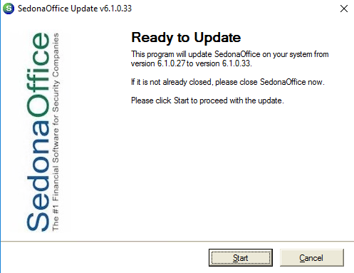
- Click Finish when the update is complete.
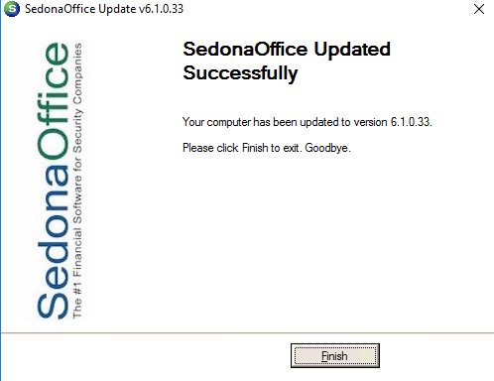

Testing SedonaOffice
- Right-click the Sedona Client shortcut and select "Run as Admin"
- Click Yes on the UAC prompt
- Log in with the default username Administrator and password Admin and click Login
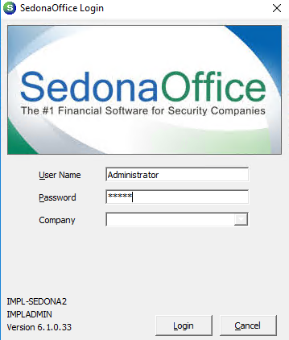
- You will be prompted to change the password, record this in the customer portal
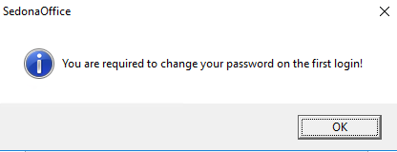
- Once you have a password set click Login
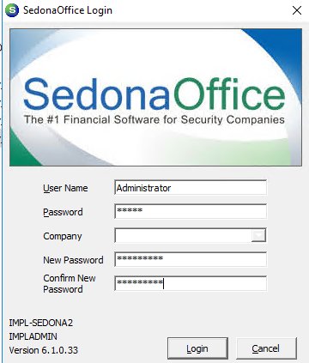
- You should now see the Sedona Office screen, the install is complete and the customer can start using Sedona.

